**نشاط خوارزميات**

**الاسم الطالب / الطالبة**

**الدكتور: خالد الكحسة**

**المستوى: الثالث**

CH.1.1

*حساب القاسم المشترك الأعظم لعددين صحيحين:

#include<iostream>

using namespace std;

void main()

{

int m,n,r;

cout<<"enter first number"<<endl;

cin>>m;

cout<<"enter second number"<<endl;

cin>>n;

while(n!=0)

{

r=m%n;

m=n;

n=r;

}

cout<<"the GCD("<<m<<","<<n<<")="<<m<<endl;

cout<<"====================================\n";

system("pause");

}

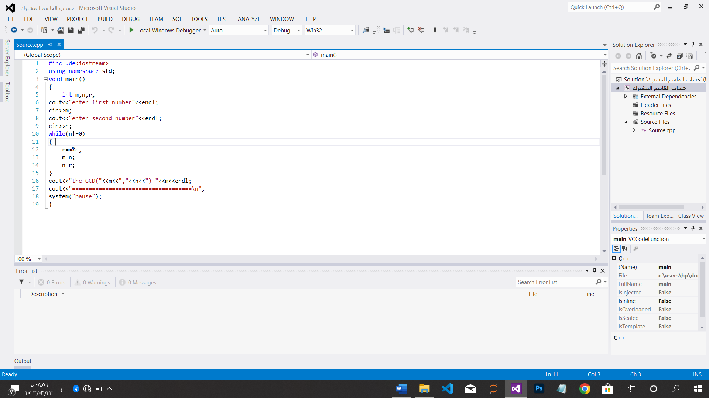

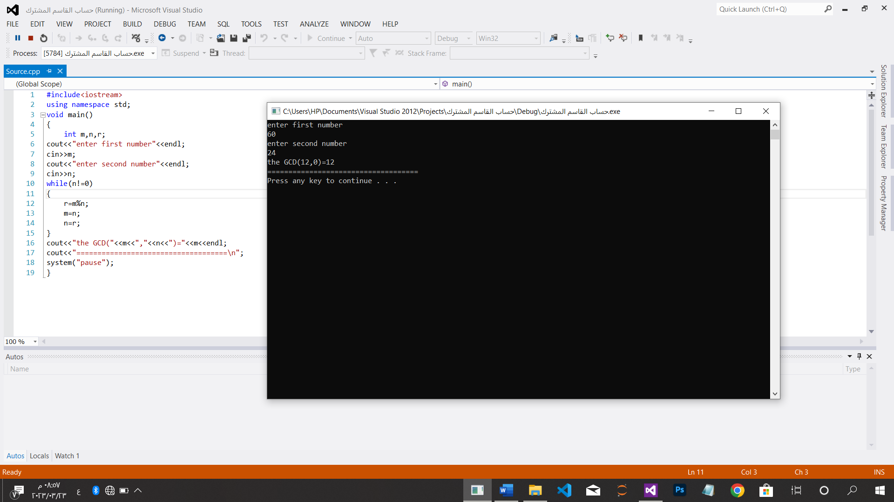

*خوارزمية فيبوناتشي التعاودية

#include<iostream>

using namespace std;

int fiboncci(int fi)

{

int *f=new int [fi];

f[0]=0;

f[1]=1;

for(int i=2;i<=fi;i++)

f[i]=f[i-1]+f[i-2];

return f[fi];

}

void main()

{

int fi;

cout<<"enter number of fiboncci="<<endl;

cin>>fi;

cout<<"================================================\n";

cout<<"fiboncci is :"<<fiboncci(fi)<<endl;

system("pause");

}

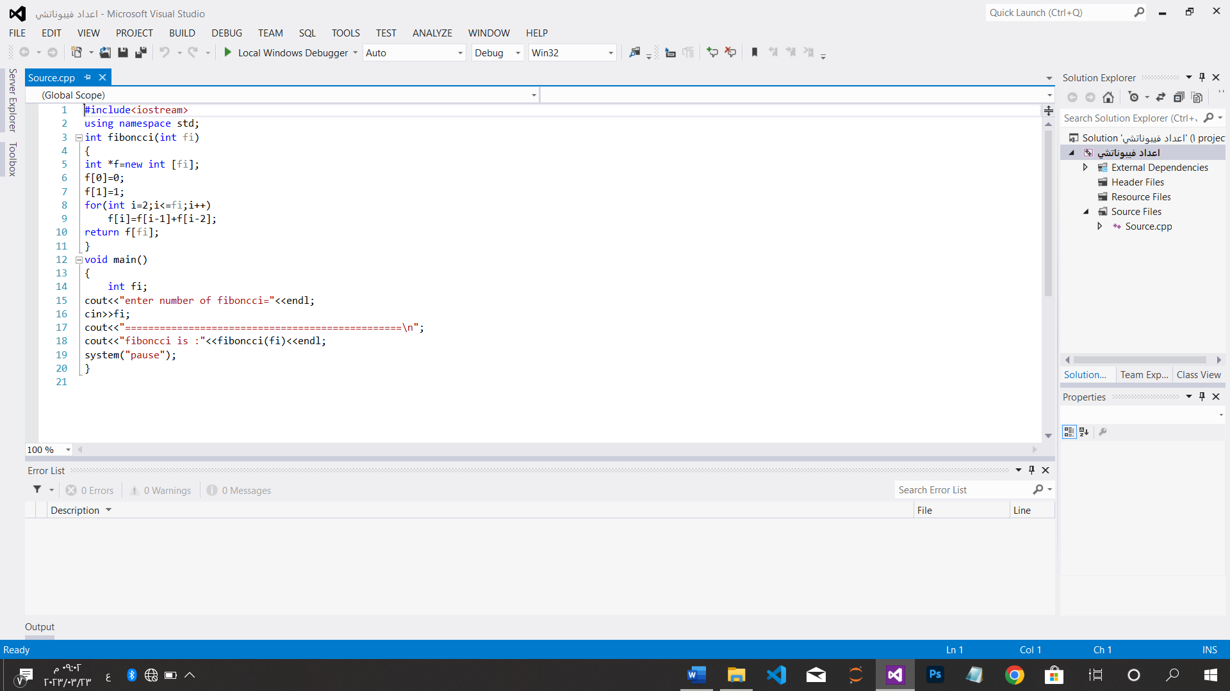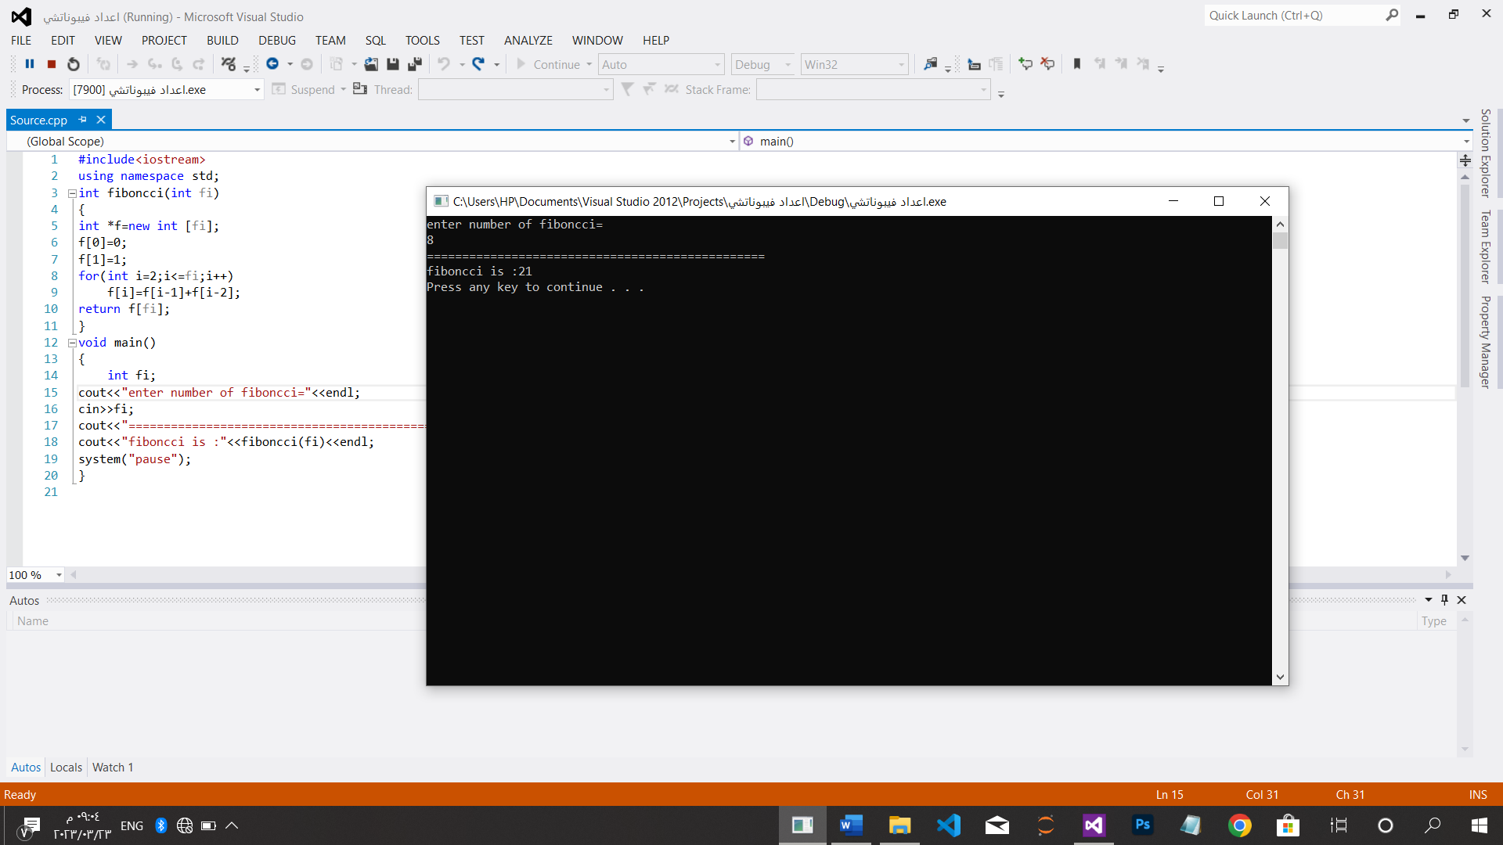

*حساب اعداد فيبوناتشي تكرارياَ

#include<iostream>

using namespace std;

int main()

{

cout<<"How many number do you want fib:\t";

int n;

cin>>n;

cout<<"================================================\n";

int *A=new int [n];

A[0]=0;

A[1]=1;

for(int i=2;i<=n;i++)

A[i]=A[i-1]+A[i-2];

cout<<"fiboncci is :"<<A[n]<<endl;

system("pause");

}

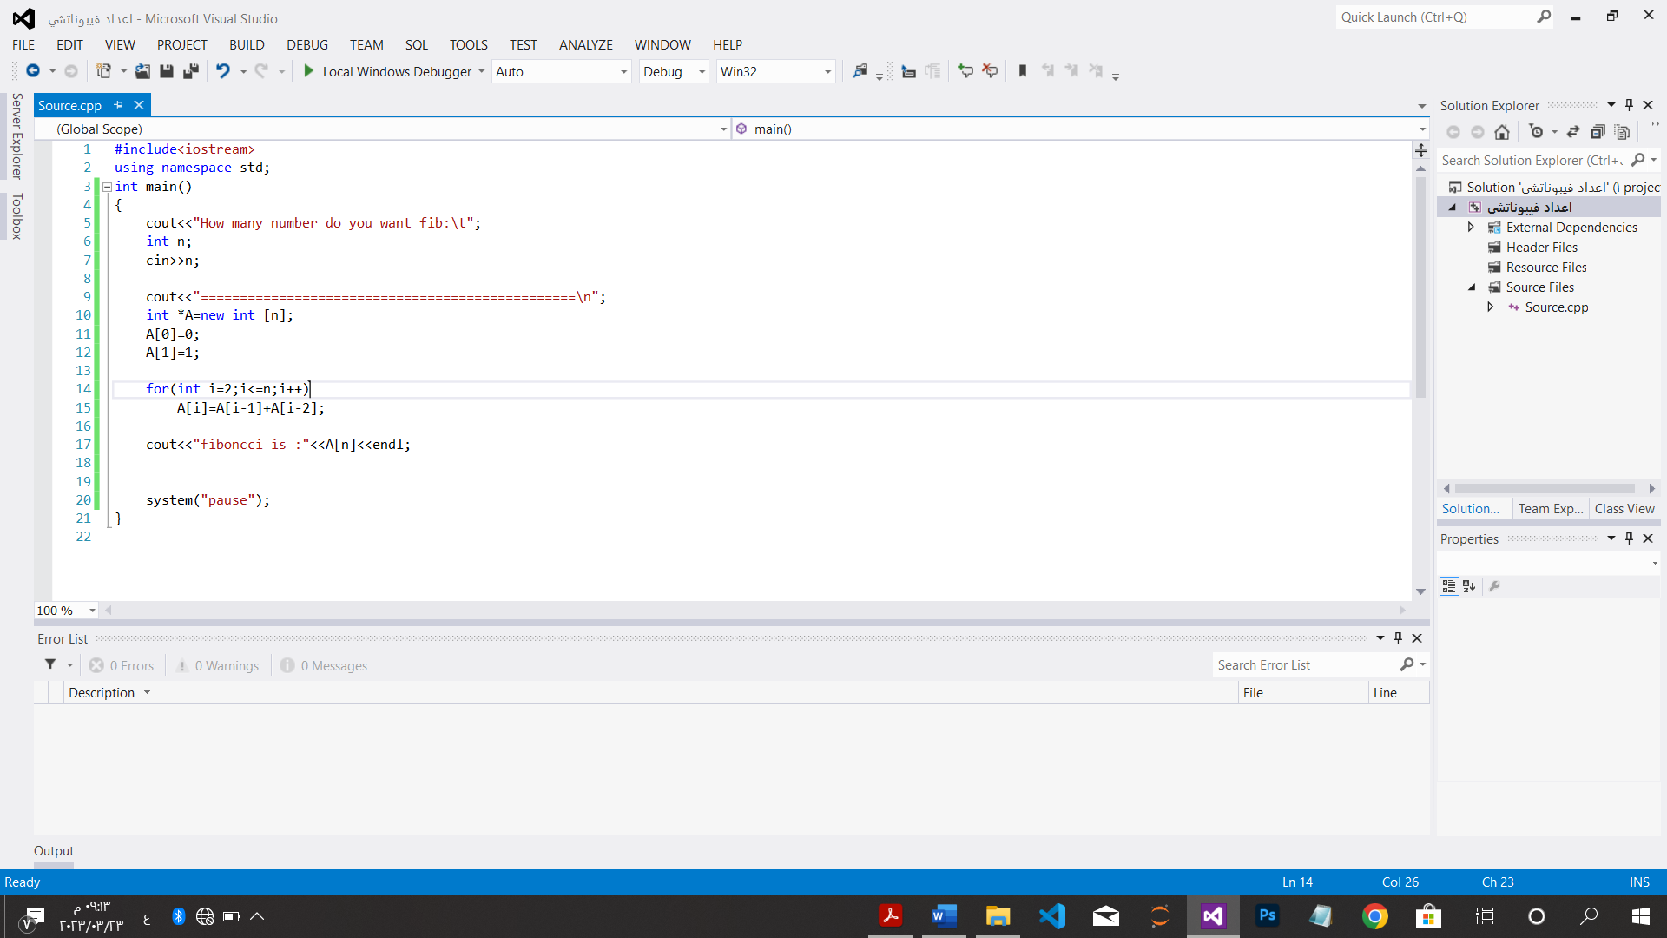

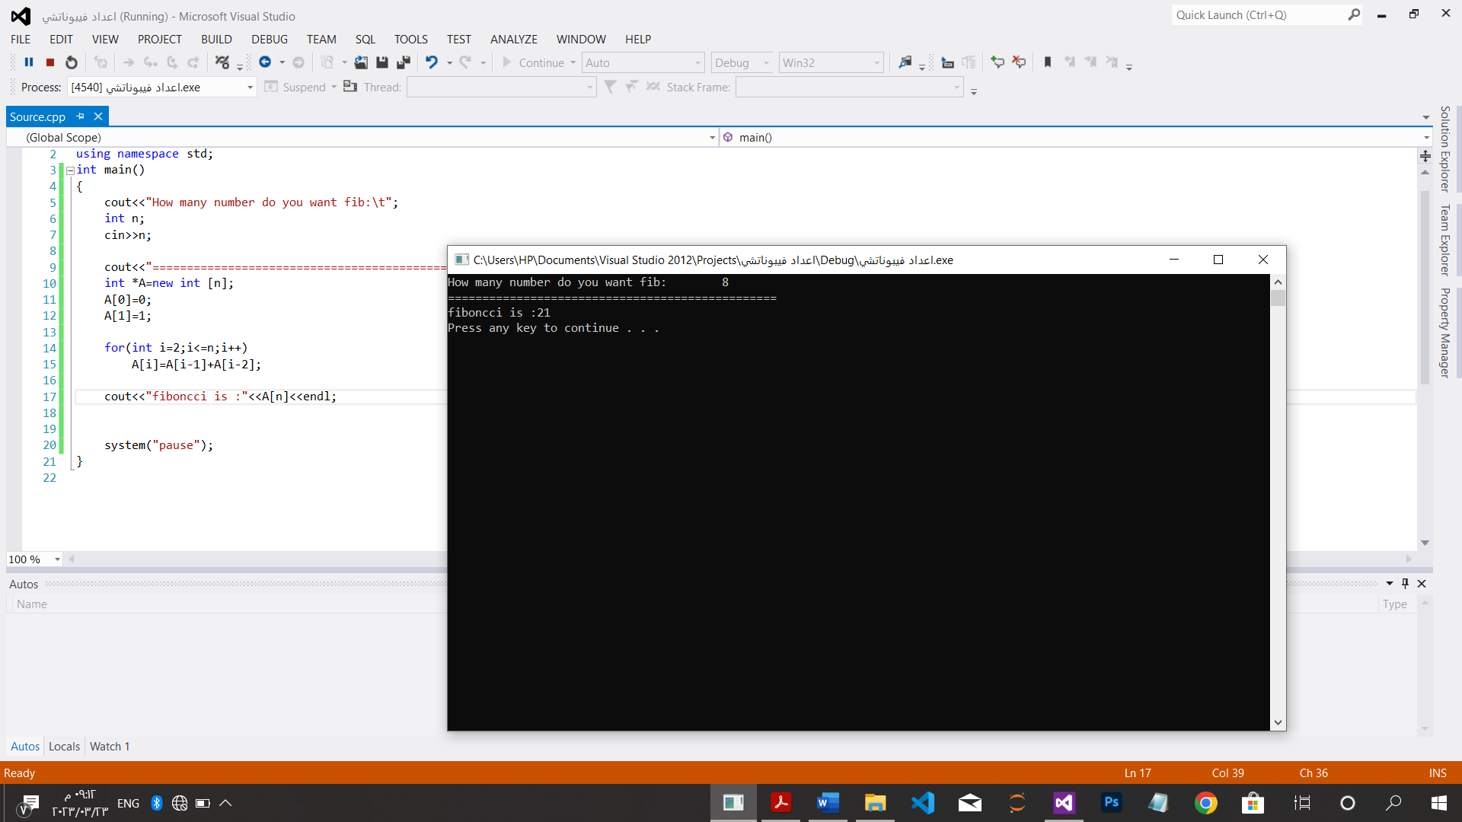

CH.2

*خوارزمية البحث التعاقبي:

#include<iostream>

using namespace std;

int search(int i,int n,int A[],int k)

{

for(int i=0;i<n;i++)

if (A[i]==k)

return i;

return -1;

}

int main()

{

int i=0,k,n;

cout<<"how many number do you want:"<<endl;

cin>>n;

cout<<"================================================\n";

int *A=new int[n];

cout<<"enter number="<<endl;

for(int i=0;i<n;i++)

cin>>A[i];

cout<<"================================================\n";

cout<<"enter number of search="<<endl;

cin>>k;

cout<<"================================================\n";

cout<<"index the number is search"<<search(i,n,A,k);

cout<<"\n================================================\n";

system("pause");

}

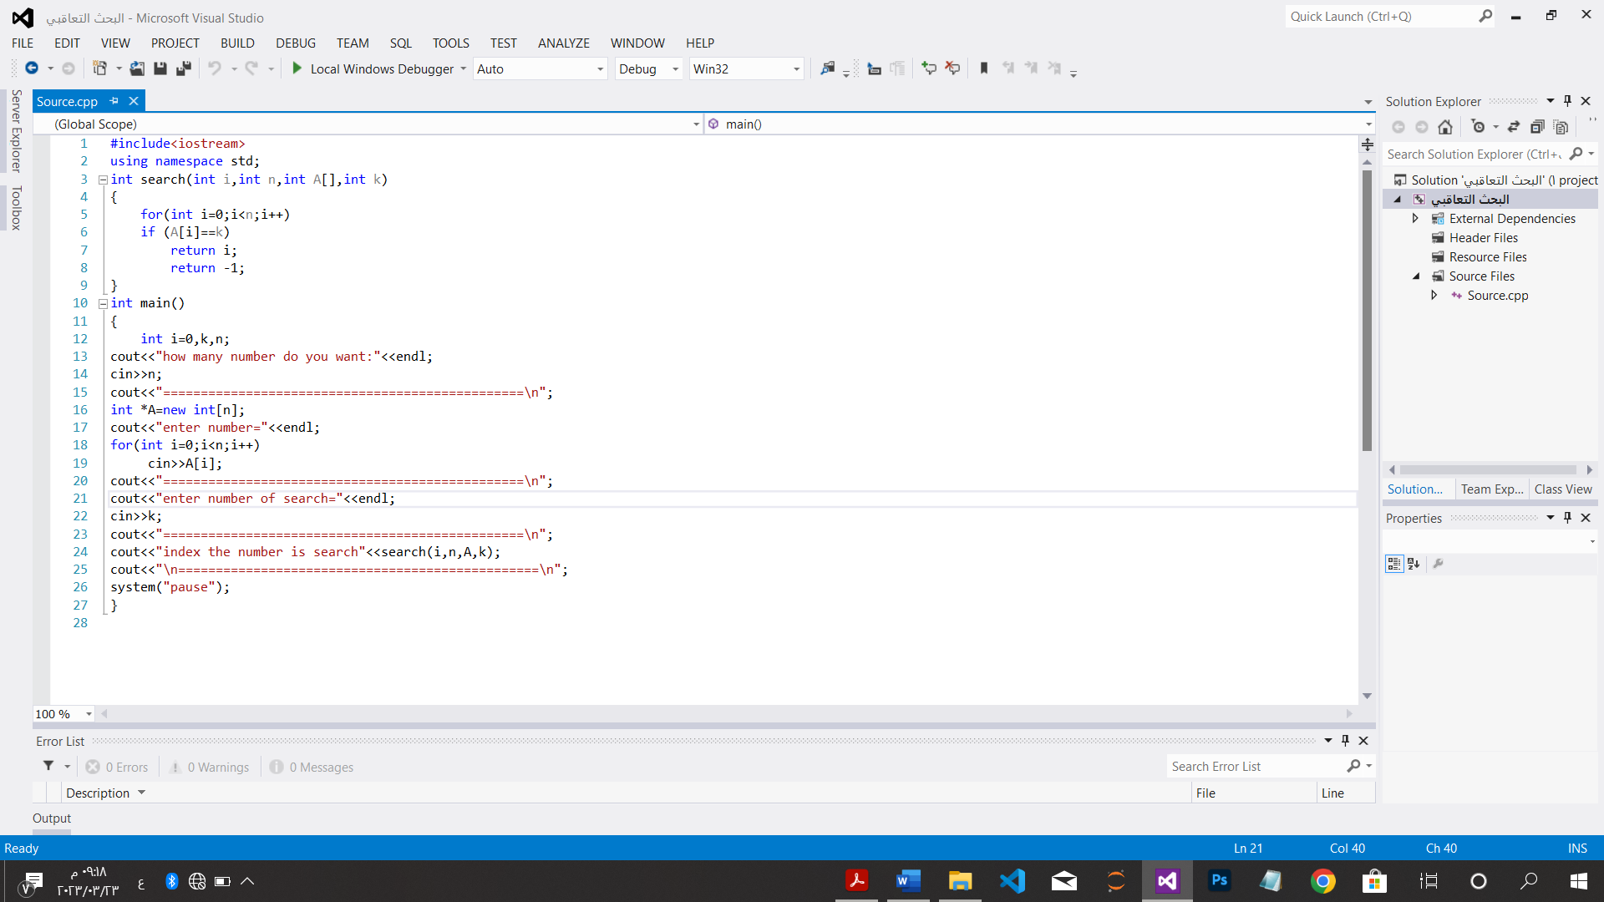

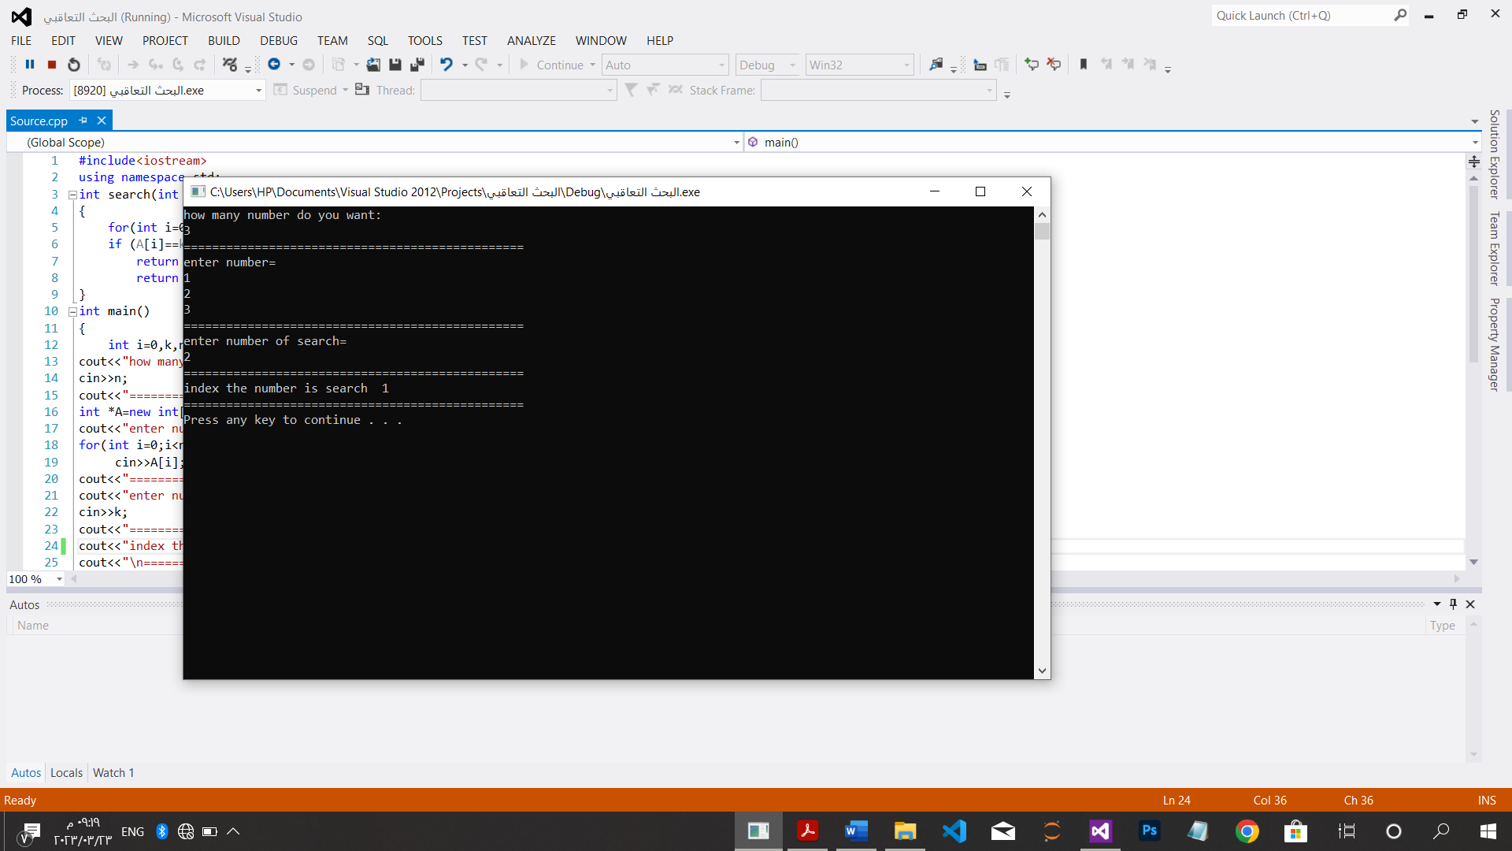

*إيجاد العنصر الأكبر:

#include<iostream>

using namespace std;

int max(int a[],int i,int n)

{

int max_val=a[0];

for(int i=0;i<n;i++)

if(max_val<a[i])

max_val=a[i];

return max_val;

}

int main()

{

int i=0,n;

cout<<"how many number do you want:"<<endl;

cin>>n;

cout<<"================================================\n";

int *A=new int[n];

cout<<"enter number="<<endl;

for(int i=0;i<n;i++)

cin>>A[i];

cout<<"================================================\n";

cout<<"The max number is:"<<max(A,i,n);

cout<<"\n================================================\n";

system("pause");

}

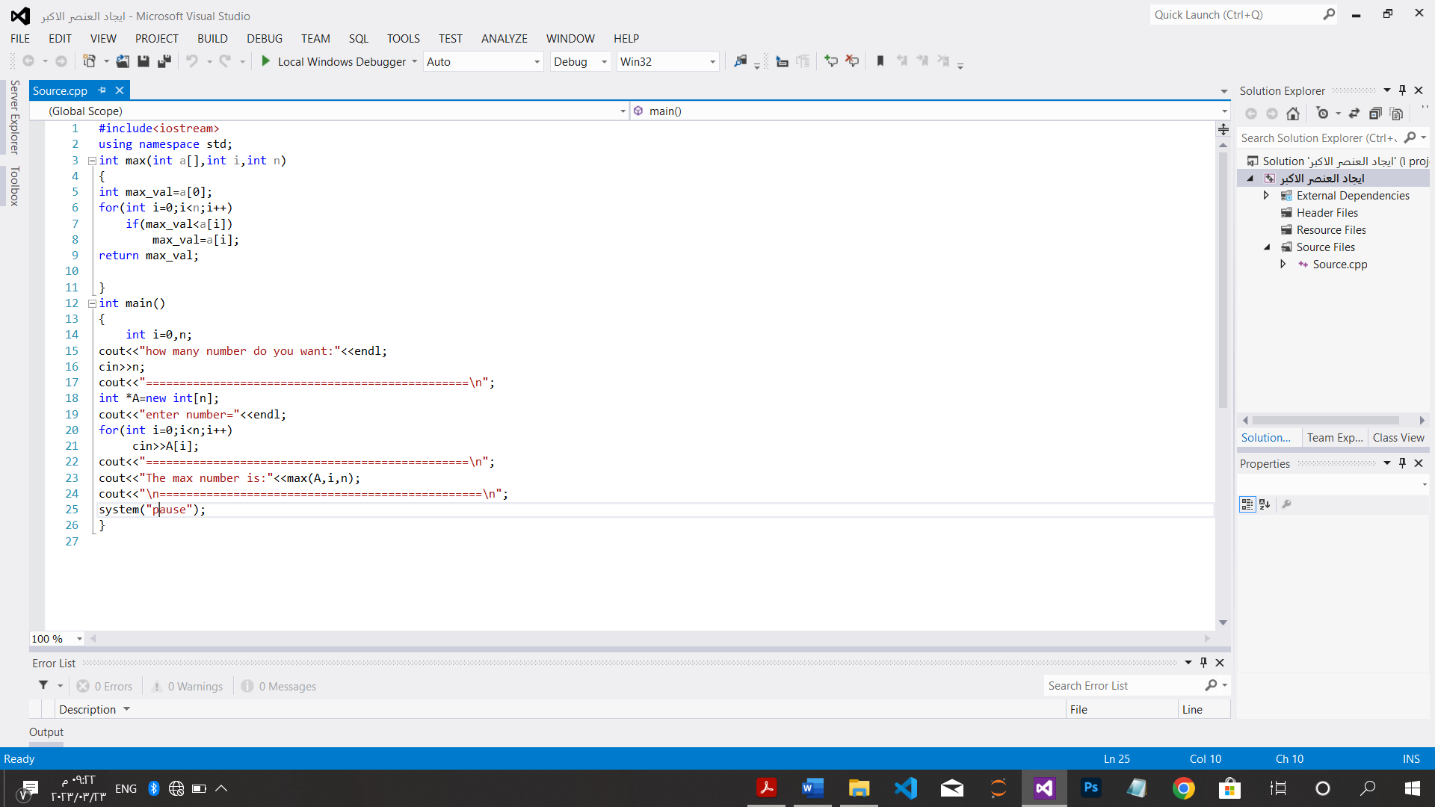

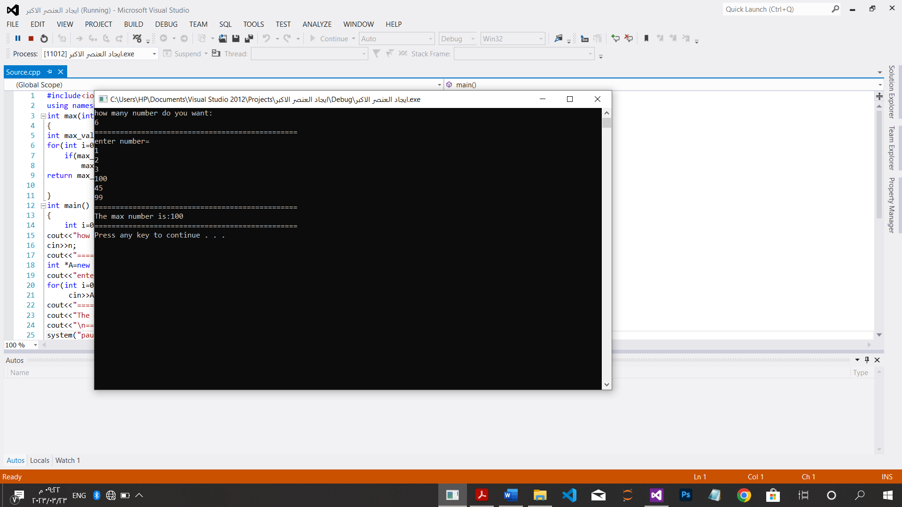

*مشكلة تفرد العناصر:

#include<iostream>

using namespace std;

int diffrent(int A[],int n)

{

for(int i=0;i<n-1;i++)

for(int j=i+1;j<n;j++)

if(A[i]==A[j])

return false;

return true;

}

int main()

{

int i=0,n;

cout<<"how many number do you want:"<<endl;

cin>>n;

cout<<"================================================\n";

int *A=new int[n];

cout<<"enter number="<<endl;

for(int i=0;i<n;i++)

cin>>A[i];

cout<<"================================================\n";

if(diffrent(A,n)==false)

cout<<"not diffrent number"<<endl;

else

cout<<" diffrent number"<<endl;

system("pause");

}

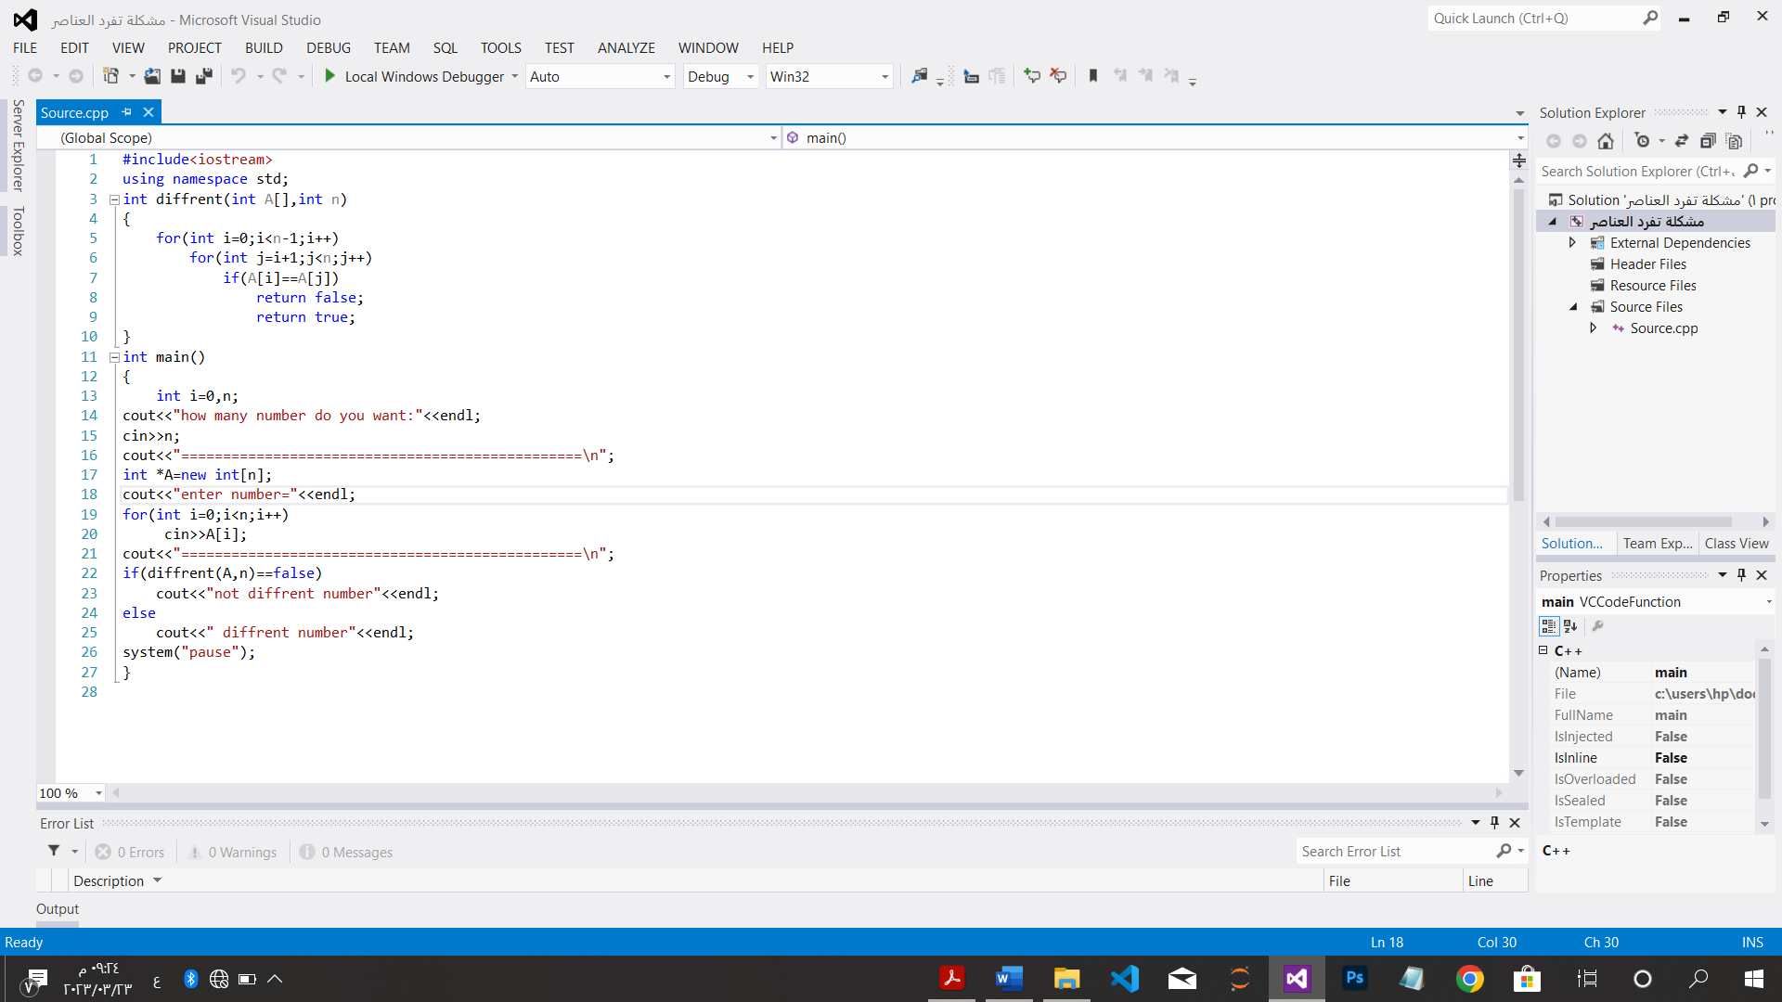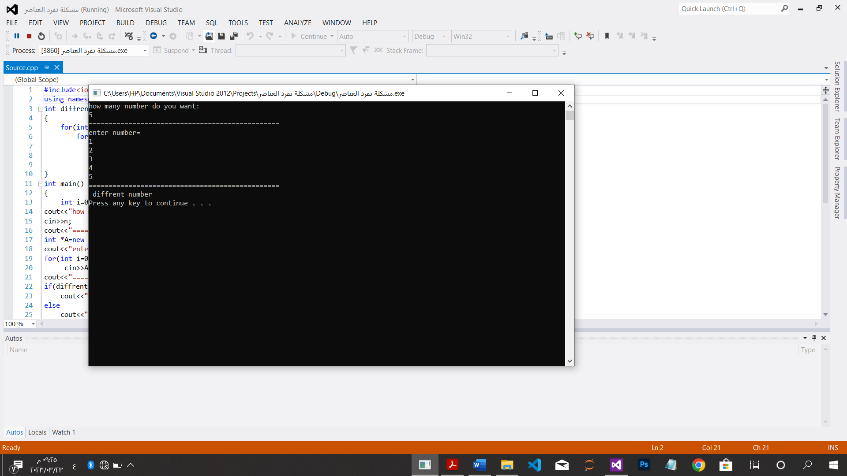

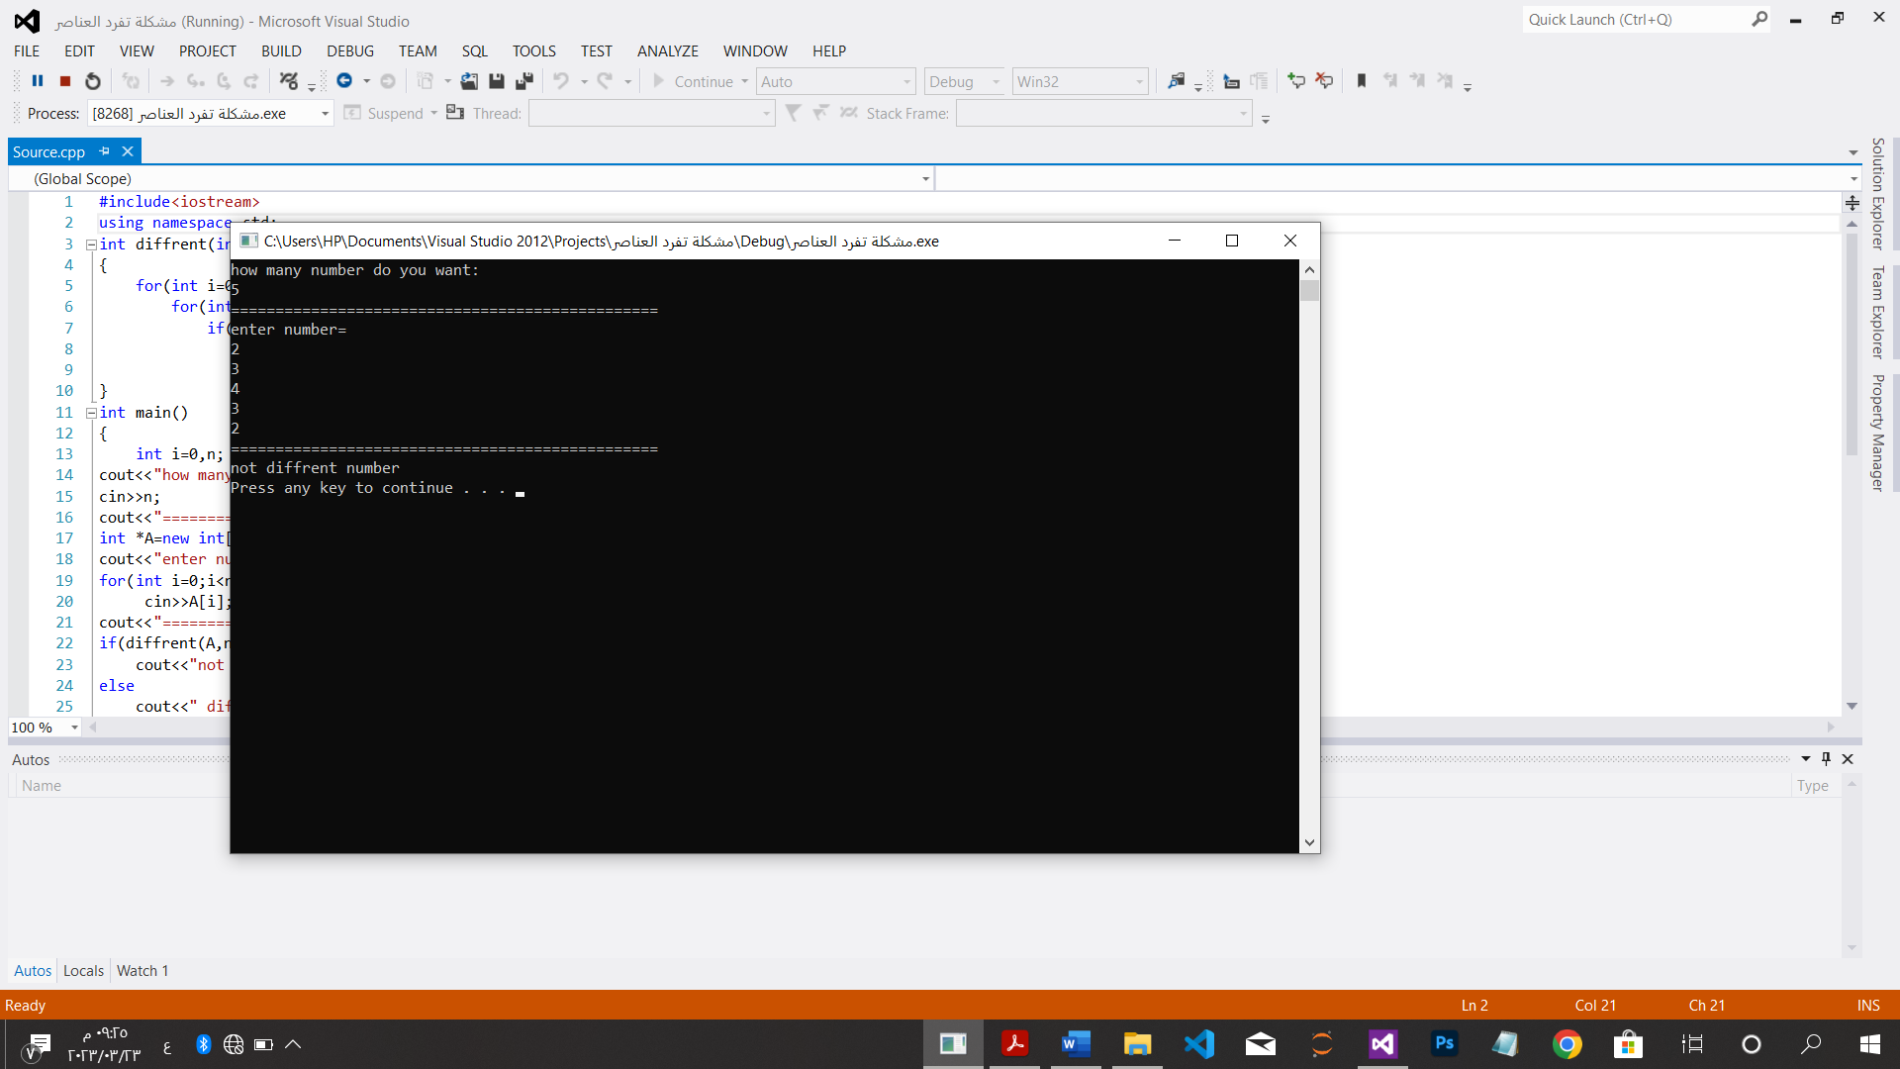

*ضرب مصفوفتين:

#include<iostream>

using namespace std;

void main()

{

int n;

cout<<"How many rows do you want:\n";

cin>>n;

int **A=new int *[n];

for(int i=0;i<n;i++)

A[i]=new int[n];

cout<<"please enter elements of A"<<endl;

for(int i=0;i<n;i++)

for(int j=0;j<n;j++)

cin>>A[i][j];

cout<<"=======================================================\n";

int **B=new int *[n];

for(int i=0;i<n;i++)

B[i]=new int[n];

cout<<"please enter elements of B"<<endl;

for(int i=0;i<n;i++)

for(int j=0;j<n;j++)

cin>>B[i][j];

int **c=new int *[n];

for(int i=0;i<n;i++)

c[i]=new int[n];

for(int i=0;i<n;i++)

for(int j=0;j<n;j++)

c[i][j]=0;

cout<<"=======================================================\n";

cout<<"mul two arrays\n";

for(int i=0;i<n;i++){

cout<<endl;

for(int j=0;j<n;j++){

for(int k=0;k<n;k++)

c[i][j]=c[i][j]+A[i][k]*B[k][j];

cout<<c[i][j]<<" ";

}

}

cout<<"\n=======================================================\n";

system("pause");

}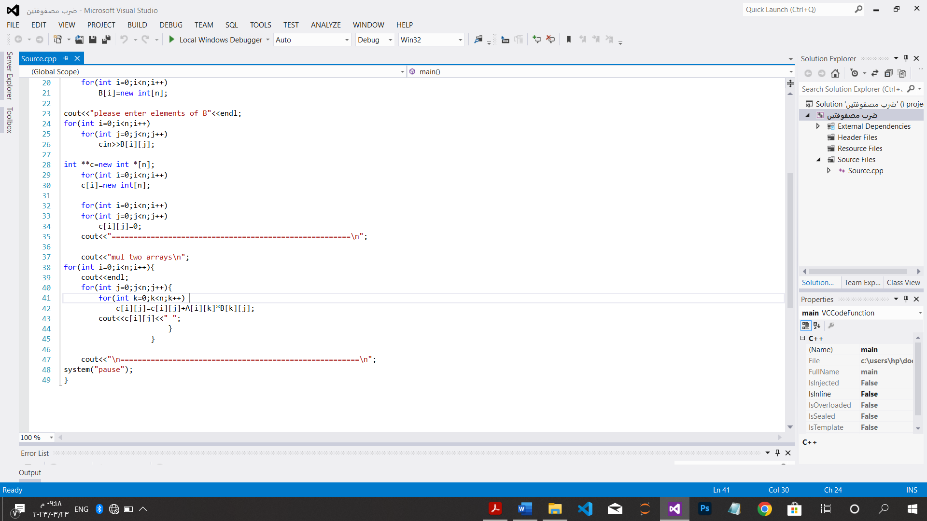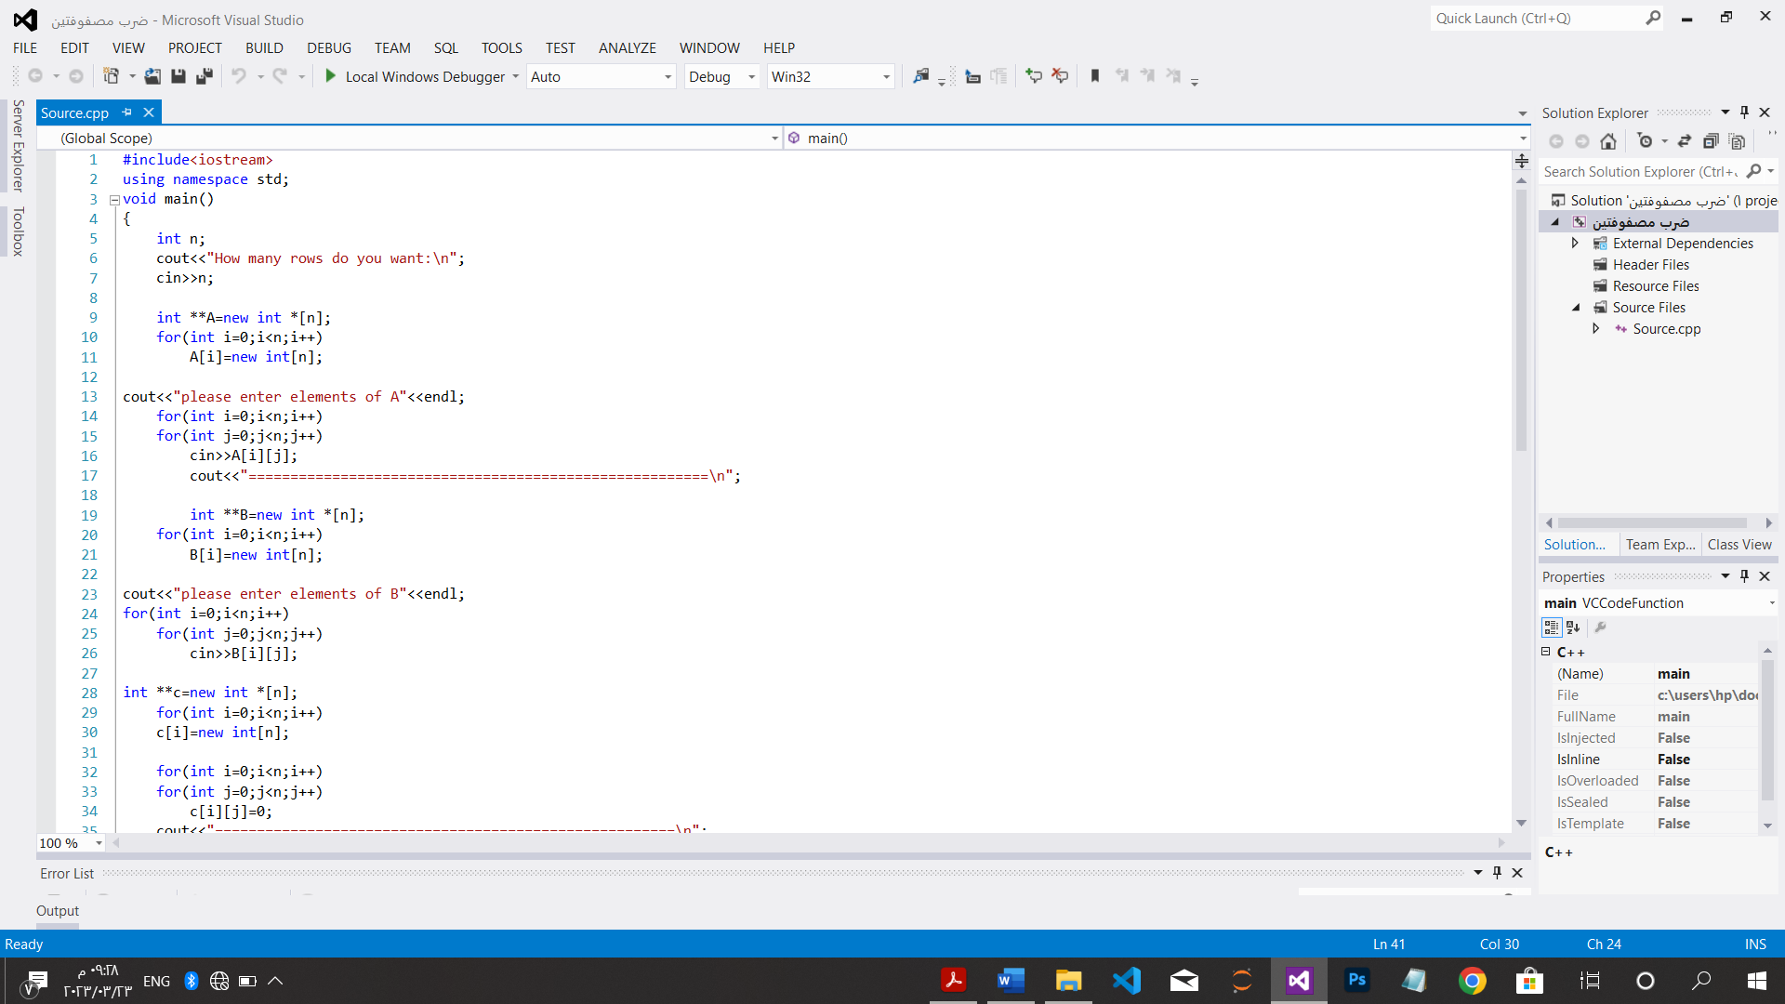

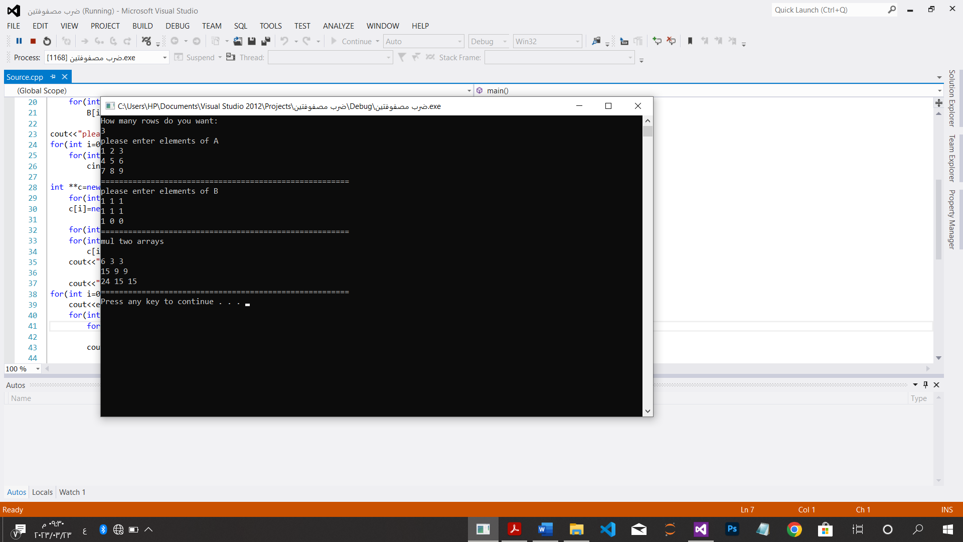

*حساب عدد الأرقام الثنائية:

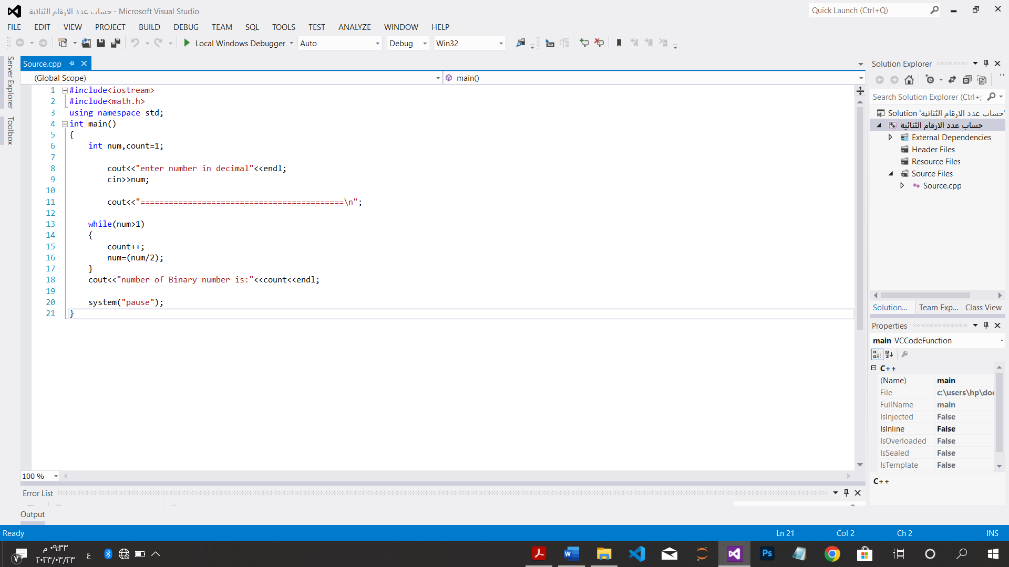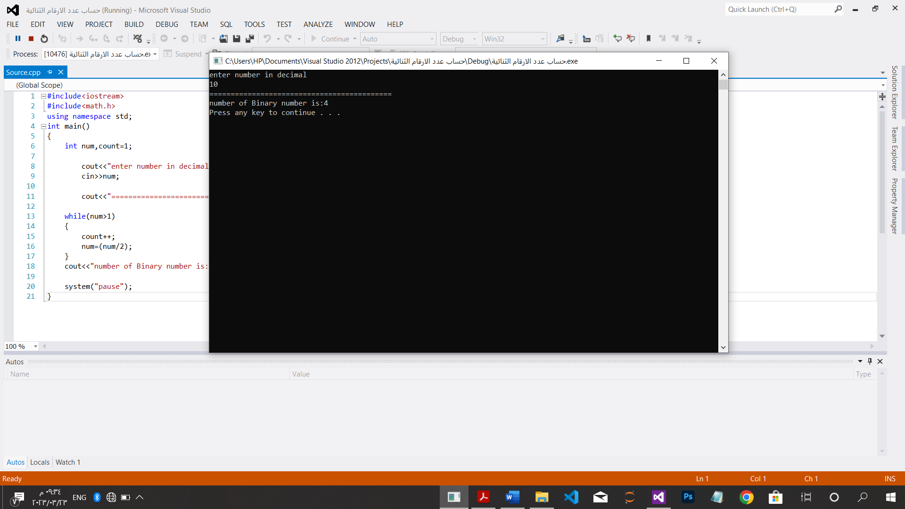

*مضروب الاعداد تعاودياَ:

#include<iostream>

using namespace std;

int fact(int n){

if(n==0)

return 1;

else

return fact(n-1)*n;

}

void main()

{

int n;

cout<<"enter number to count factoria"<<endl;

cin>>n;

int x=fact(n);

cout<<"the factoril is:"<<x<<endl;

cout<<"=============================================\n";

system("pause");

}

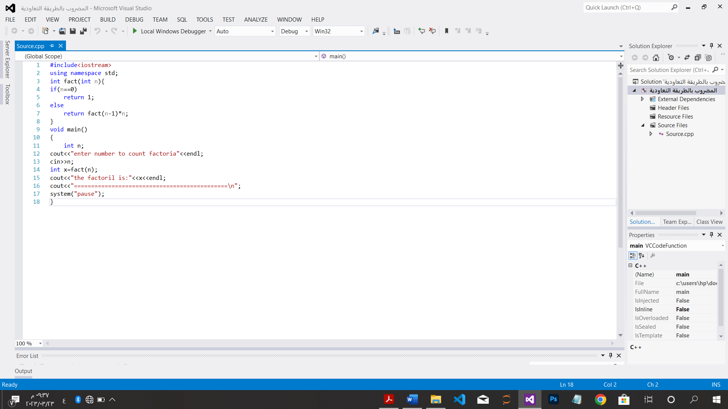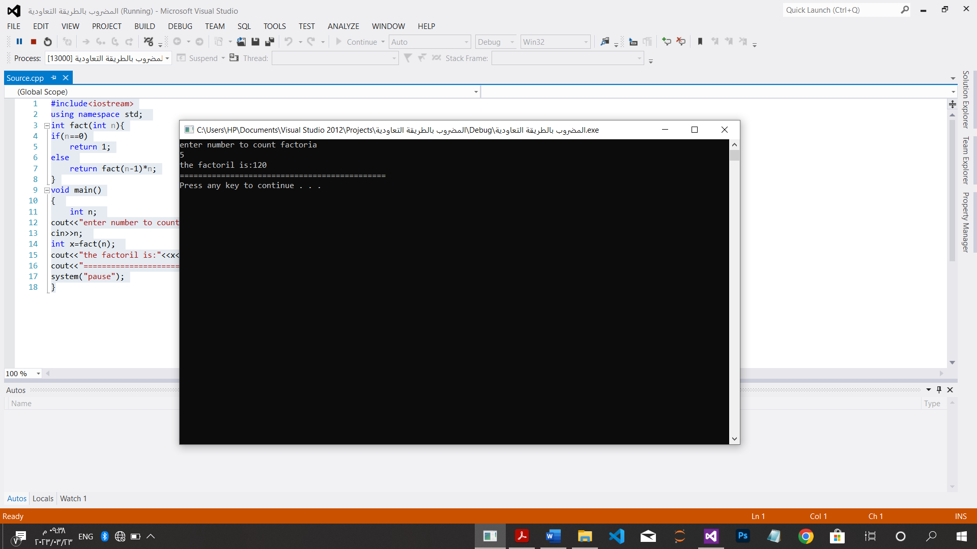

*مضروب الاعداد تكرارياَ:

#include<iostream>

using namespace std;

int main()

{

int n,f=1;

cout<<"enter number to count factoria"<<endl;

cin>>n;

cout<<"=============================================\n";

for(int i=1;i<=n;i++)

f*=i;

cout<<"the factoril is:"<<f<<endl;

cout<<"=============================================\n";

system("pause");

}

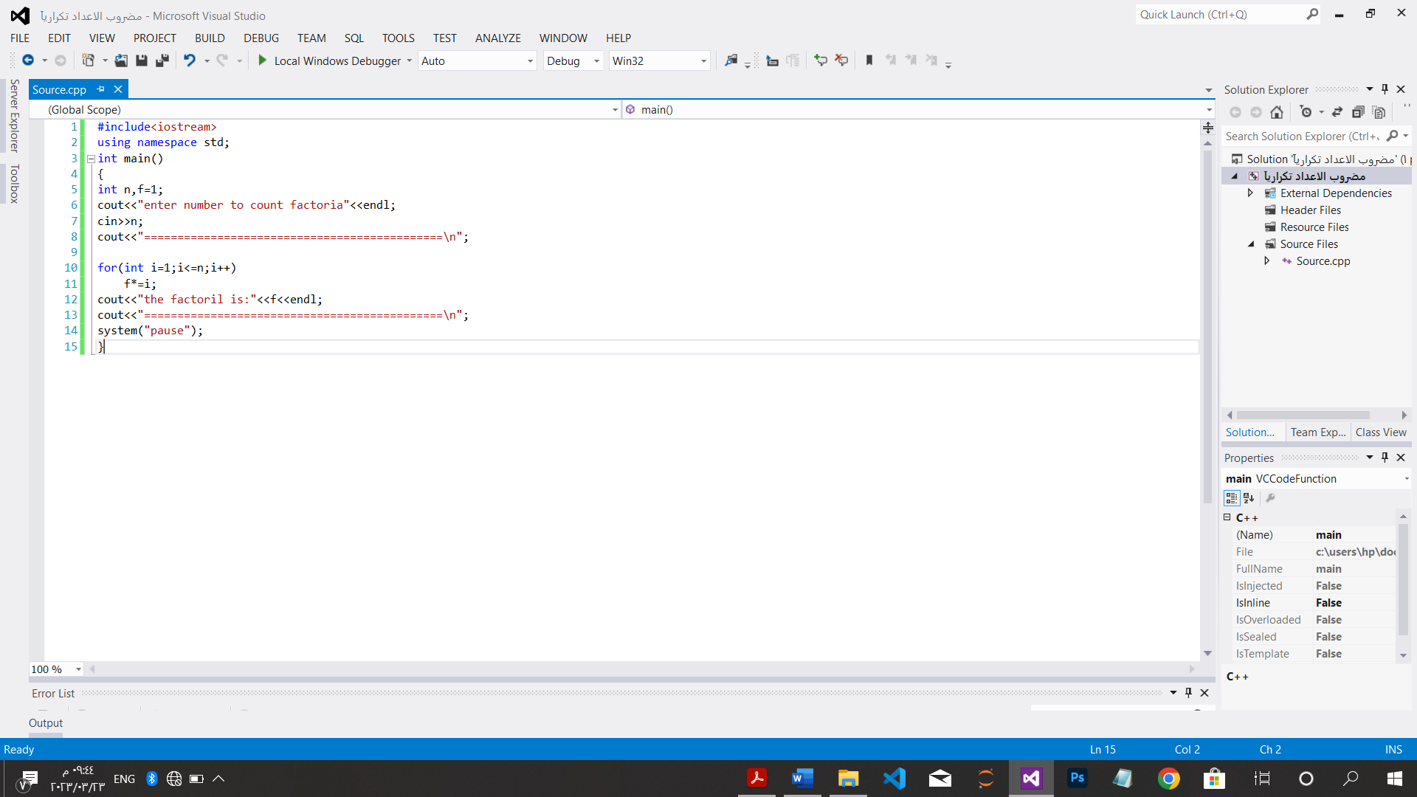

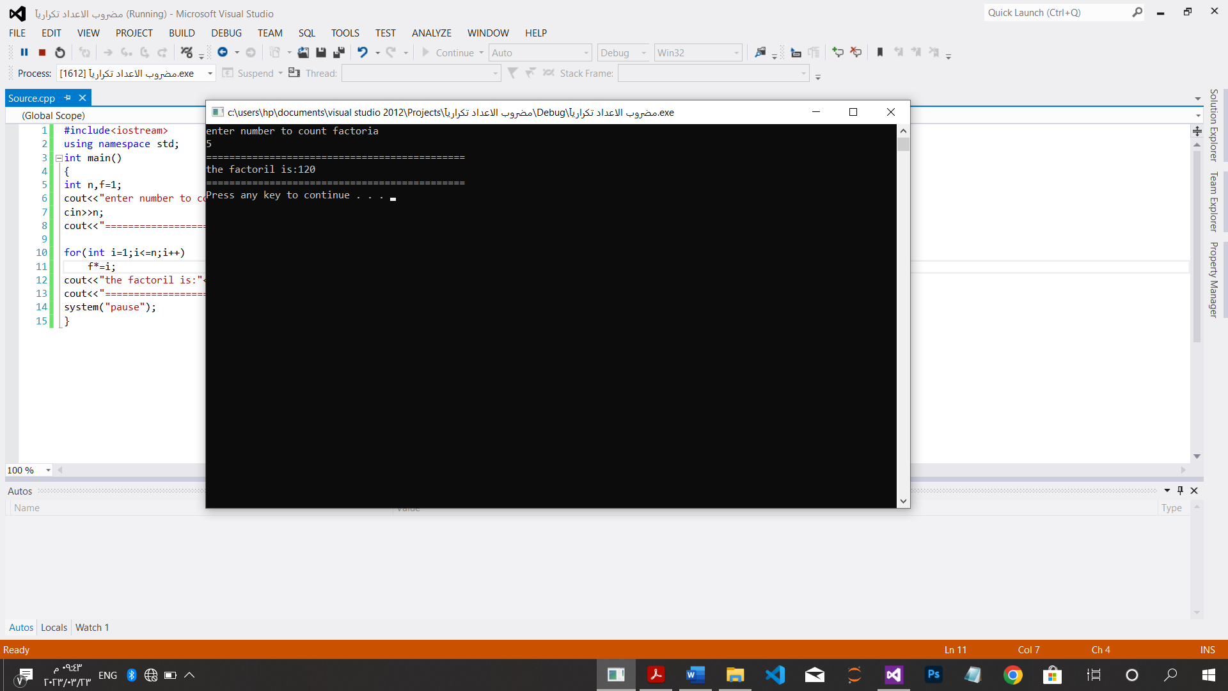

*لغز أبراج هانوي:

#include<iostream>

using namespace std;

int Hanoi(int n){

if(n==1)

return 1;

else

return 2*Hanoi(n-1)+1;

}

int main(){

int n;

cout<<"enter number of disck"<<endl;

cin>>n;

cout<<"number is ="<<Hanoi(n)<<endl;

cout<<"=============================================\n";

system("pause");

}

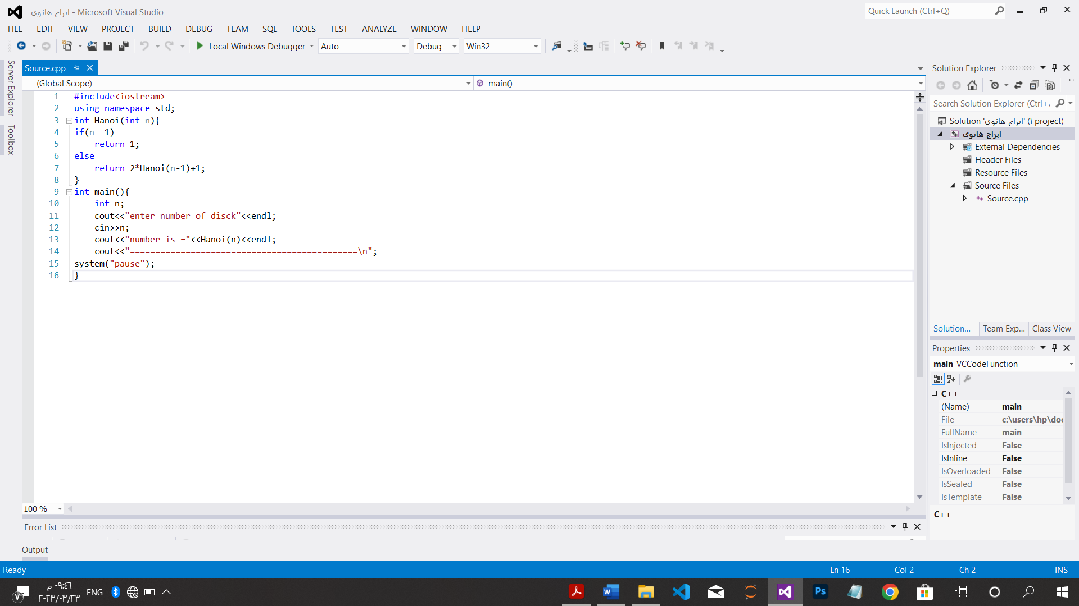

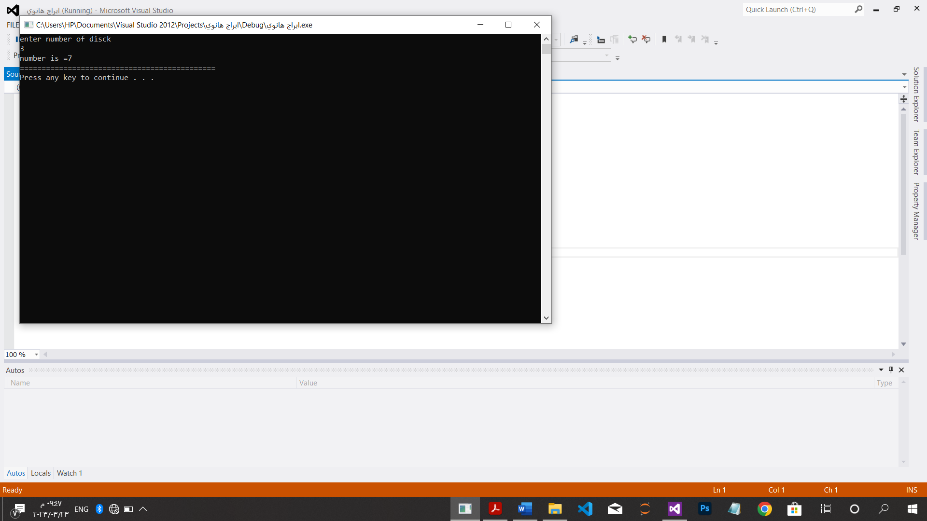

*عدد الأرقام الثنائية تعاودياَ:

#include<iostream>

using namespace std;

int BinRec(int n){

if(n==1)

return 1;

else

return BinRec(n/2)+1;

}

int main(){

int n;

cout<<"enter number :";

cin>>n;

cout<<"the count number in Binary is:"<<BinRec(n)<<endl;

cout<<"=============================================================\n";

system("pause");

}

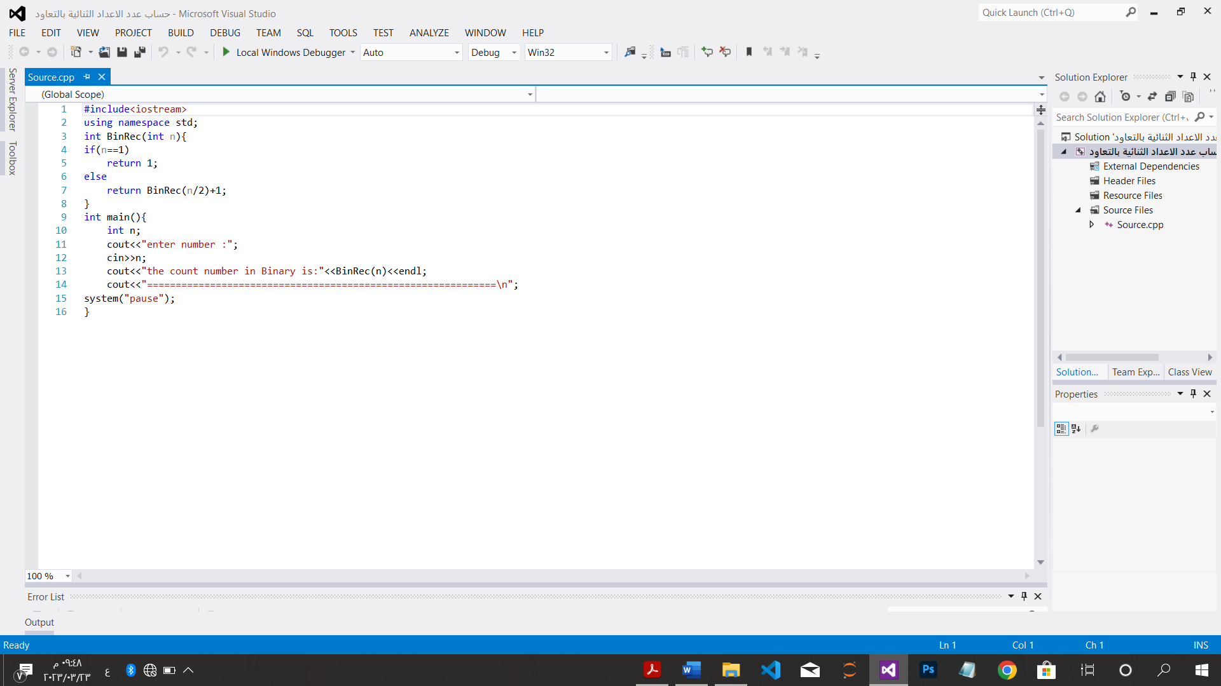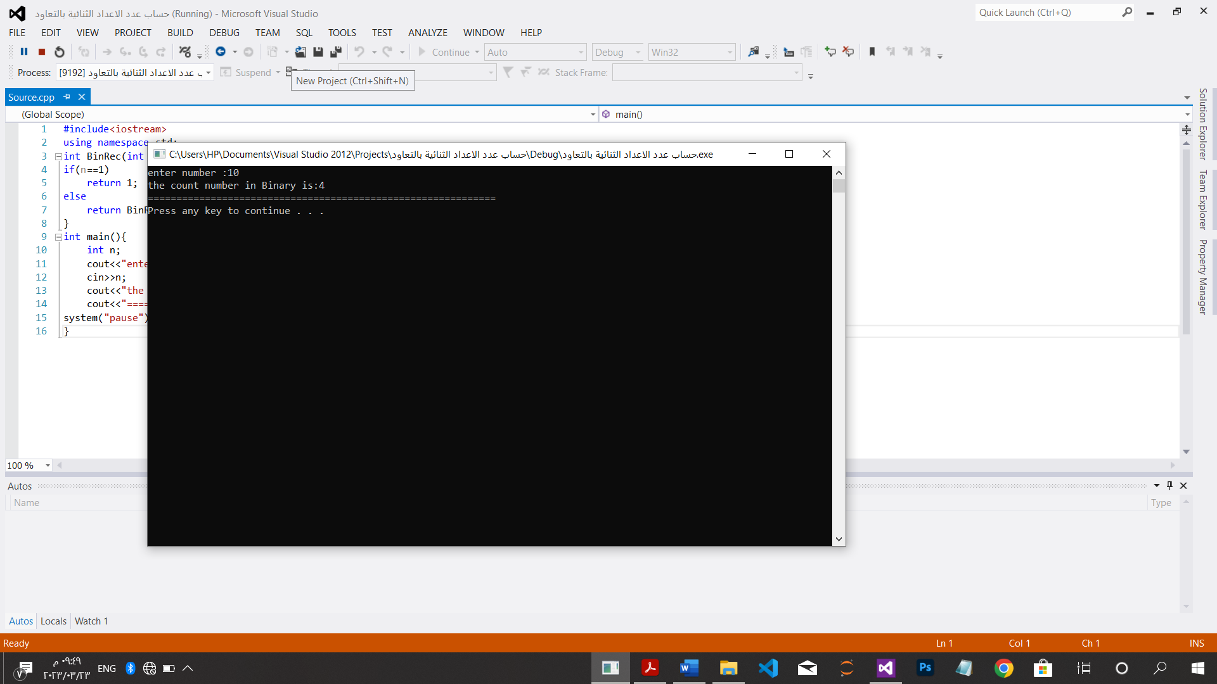

CH.3

*خوارزمية ترتيب الاختيار بالقوة الغاشمة:

#include<iostream>

using namespace std;

int main()

{

int m;

cout<<"How many number do you want=";

cin>>m;

int *A=new int[m];

cout<<"enter elements of Array:"<<endl;

for(int i=0;i<m;i++)

cin>>A[i];

cout<<"====================================\n";

for(int i=0;i<m-1;i++){

int min=i;

for(int j=i+1;j<m;j++)

if(A[j]<A[min])

min=j;

int temp=A[i];

A[i]=A[min];

A[min]=temp;

}

cout<<"the elements after sorting are:"<<endl;

for(int i=0;i<m;i++)

cout<<A[i]<<" ";

cout<<"\n====================================\n";

system("pause");

}

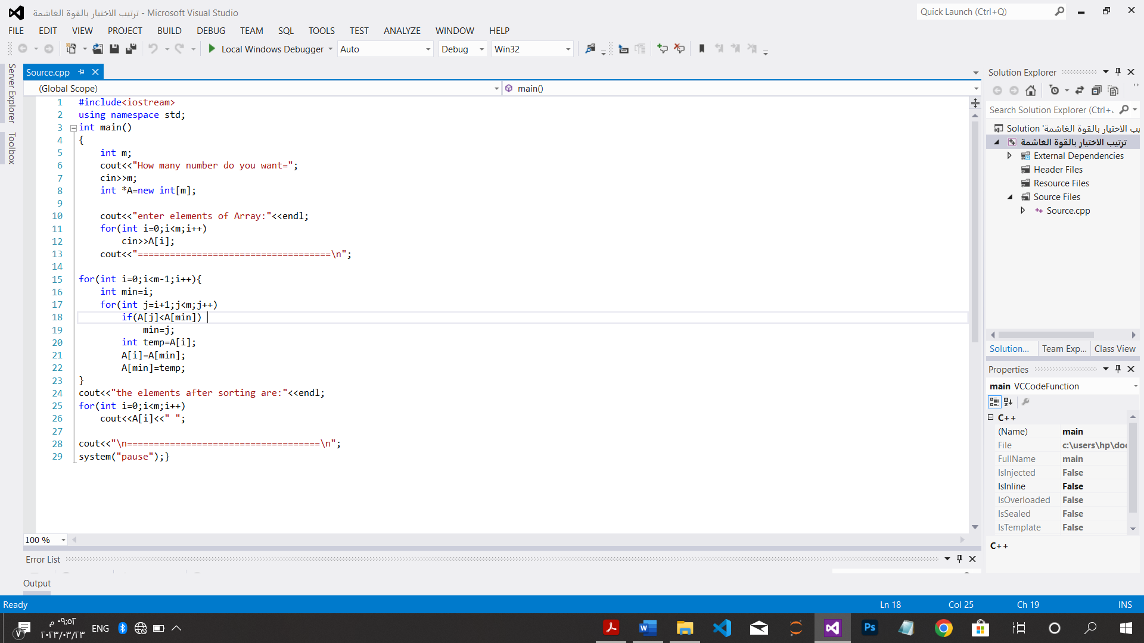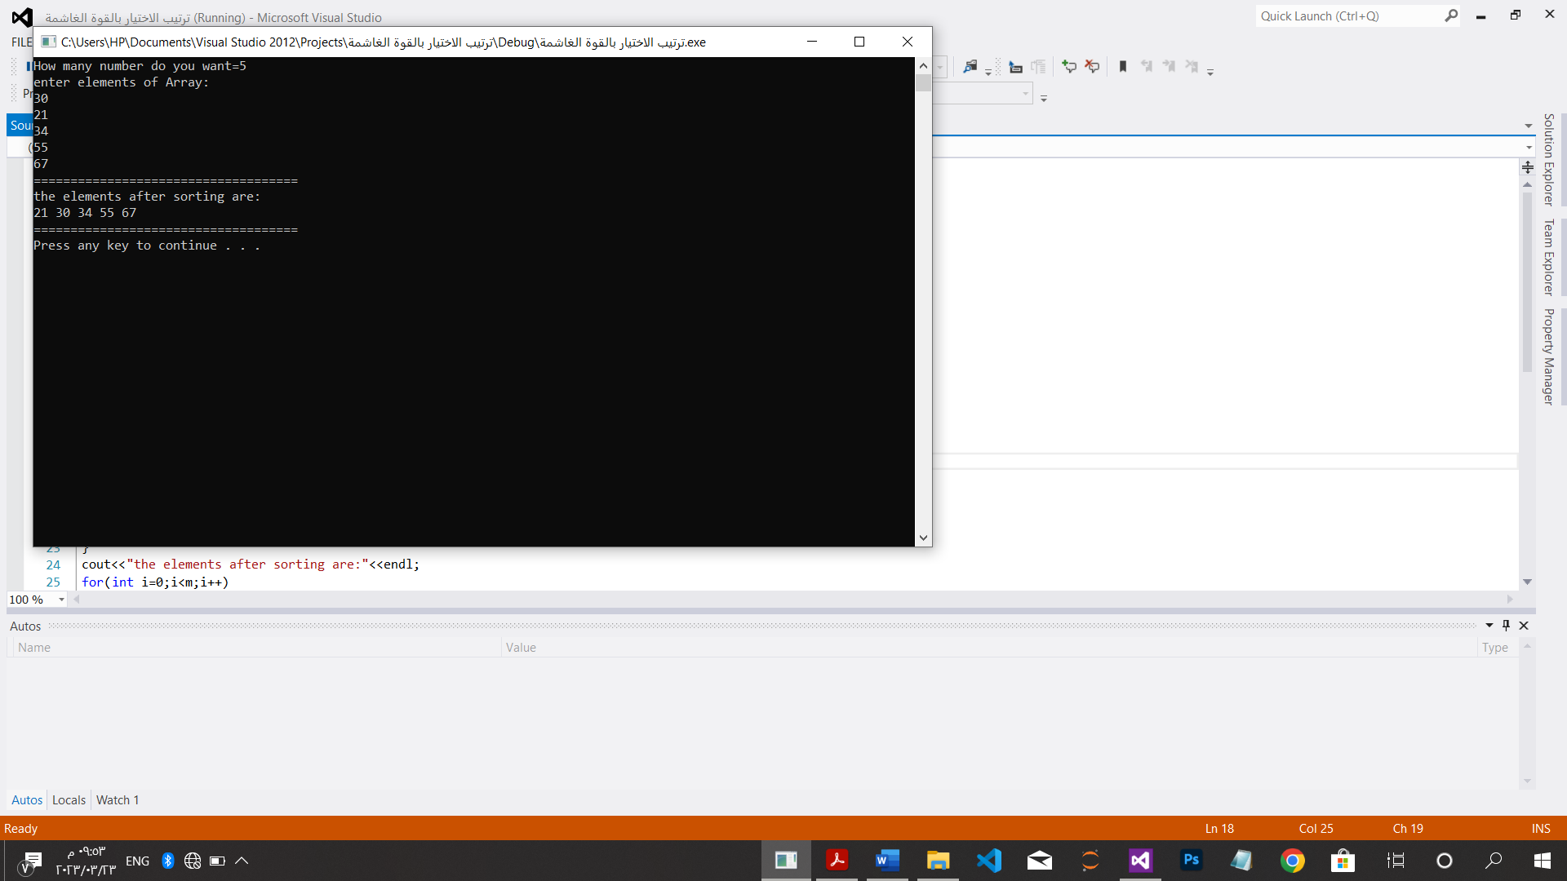

*خوارزمية الترتيب الفقاعي بالقوة الغاشمة:

#include<iostream>

using namespace std;

int main(){

int temp,n;

cout<<"How many number do you want=\t";

cin>>n;

int *A=new int[n];

cout<<"enter five numbers to order them:"<<endl;

for(int i=0;i<n;i++)

cin>>A[i];

for(int i=0;i<=n-2;i++){

for(int j=0;j<=n-2-i;j++){

if(A[j+1]<A[j]){

swap(A[j],A[j+1]);}

}

}

cout<<"the numbers after sorting:"<<endl;

for(int i=0;i<n;i++)

cout<<A[i]<<" ";

cout<<endl;

system("pause");

}

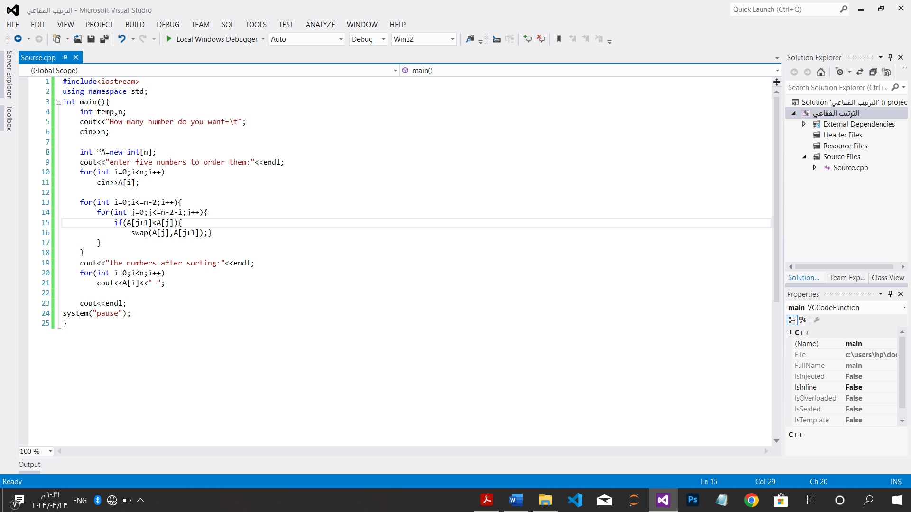

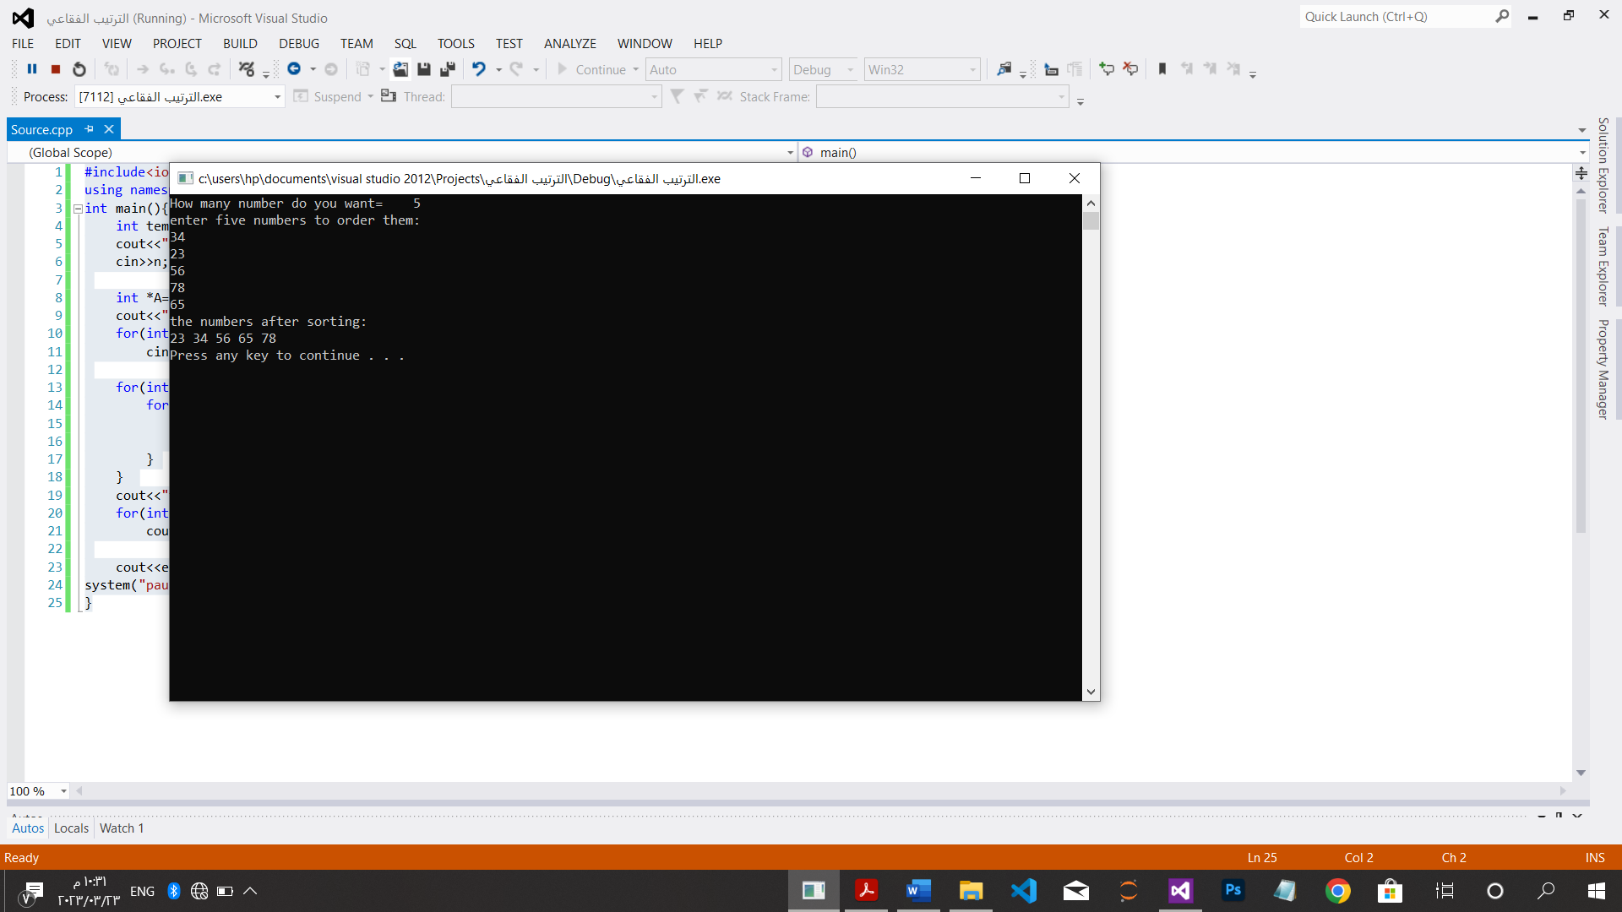

*مطابقة خيط رمزي بالقوة الغاشمة:

#include<iostream>

using namespace std;

int match(char T[],int m,char p[],int n){

int j;

for(int i=0;i<=m-n;i++) {

j=0;

while((j<m)&&(p[j]==T[i+j]))

j=j+1;

if(j==n)

return i;}

}

int main(){

int x ,t1,t2;

cout<<"How many character a text :";

cin>>t1;

cout<<"How many character a pattern :";

cin>>t2;

char *T=new char[t1],*p=new char[t2];

cout<<"enter text"<<endl;

for(int i=0;i<t1;i++)

cin>>T[i];

cout<<"===========================================\n";

cout<<"enter pattern"<<endl;

for(int j=0;j<t2;j++)

cin>>p[j];

cout<<"===========================================\n";

cout<<"location is="<<match(T,t1,p,t2)<<endl;

cout<<"===========================================\n";

system("pause");

}

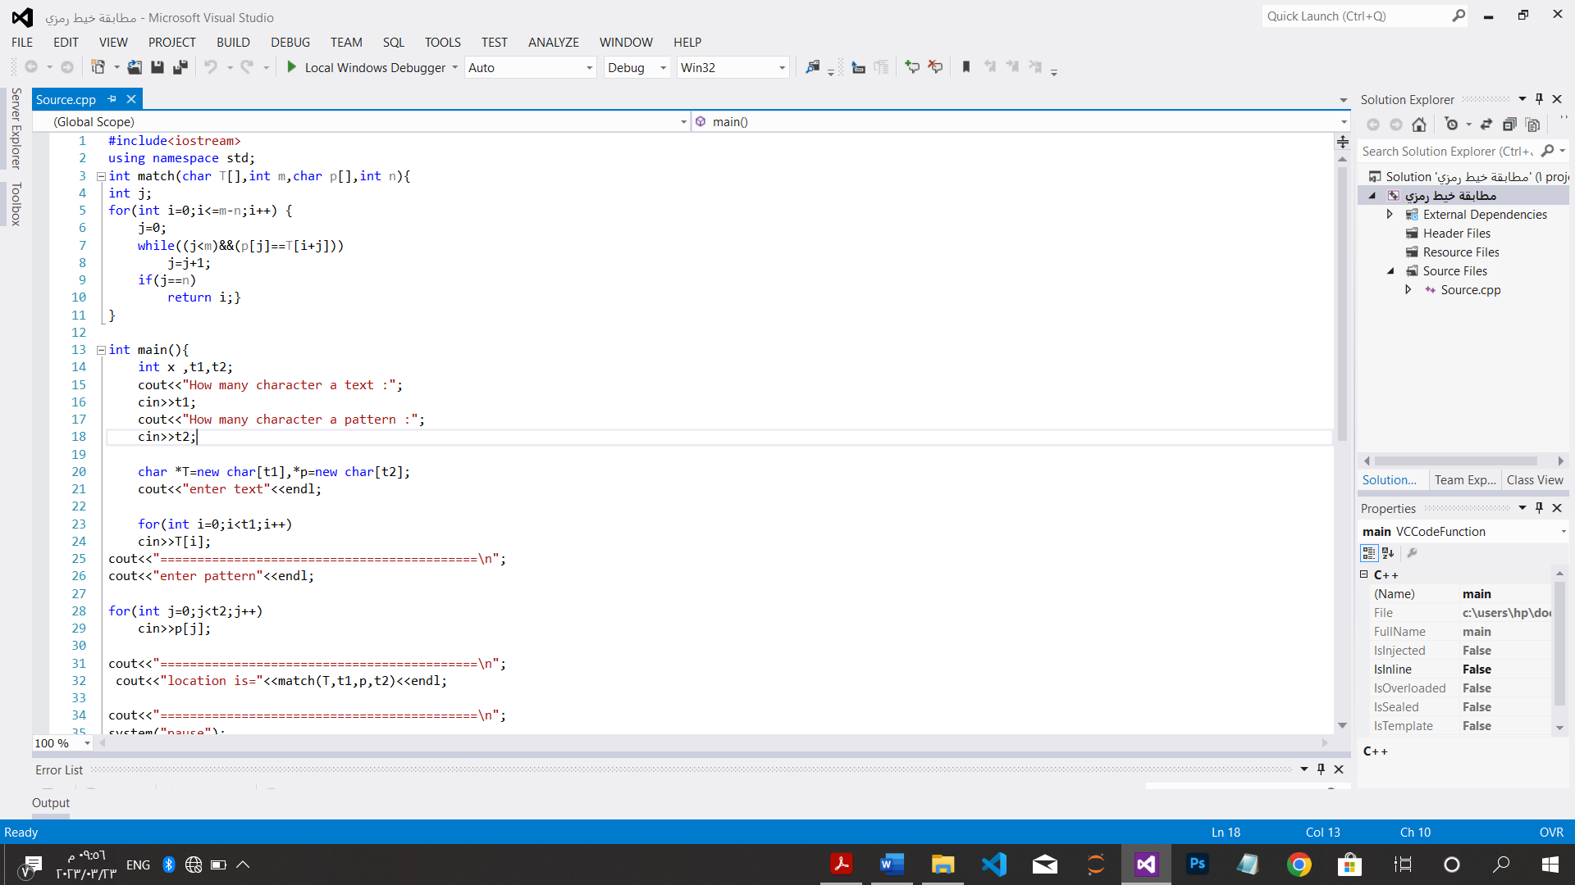

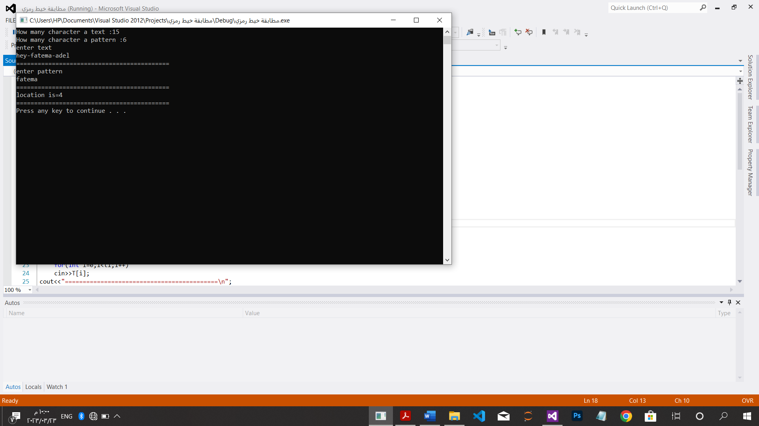

*اقرب زوج:

#include<iostream>

#include<math.h>

using namespace std;

int main(){

double d=0;

int a;

cout<<"enter How many number do you want=\t";

cin>>a;

cout<<"=====================================\n";

int *p=new int[a];

cout<<"enter the points :"<<endl;

for(int i=0;i<a;i++)

cin>>p[i];

cout<<"=====================================\n";

for(int i=1;i<a;i++)

for(int j=i+1;j<a;j++)

d=min(d,sqrt(((i-j)*(i-j)))+((i-j)*(i-j)));

cout<<"the distance between the closet pair of point is:"<<d<<endl;

cout<<"=====================================\n";

system("pause");

}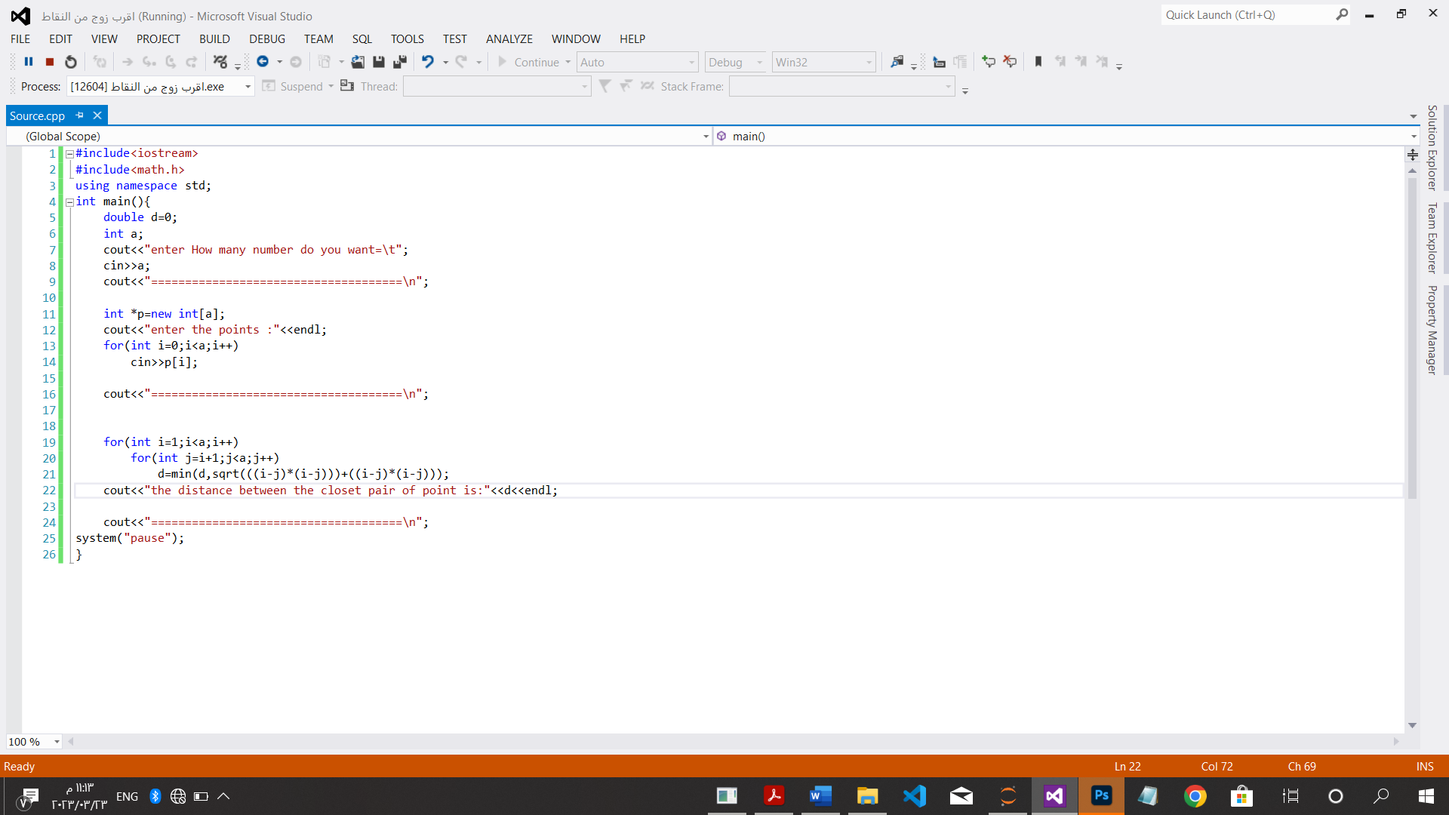

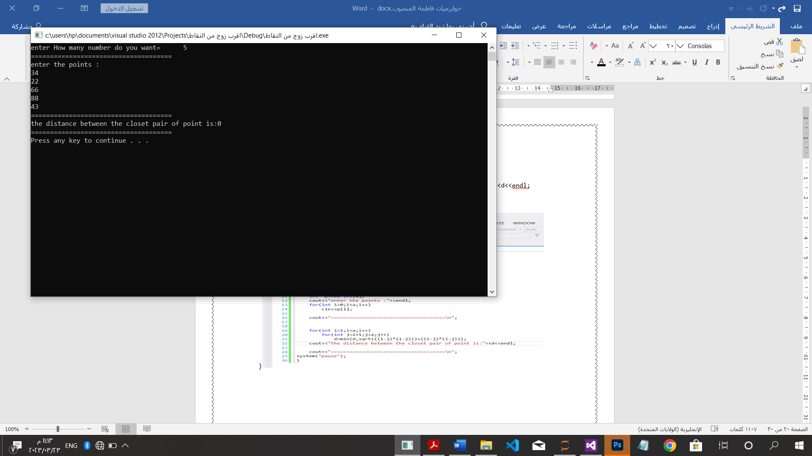

CH: 5.1,5.2

*ترتيب الدمج:

#include<iostream>

using namespace std;

void merge(int B[],int d,int c[],int l,int A[],int n){

int I,j,k;

i=j=k=0;

while(i<d && j<l){

if(B[i]<=c[j]){

A[k]=B[i];

i++;

}

else{

A[k]=c[j];

j++;

}

k=k+1;

}

if(i==d){

for(int s=j;s<l;s++)

A[k]=c[s];

k++;

}

else{

for(int s=I;s<d;s++)

A[k]=B[s];

k++;}

}

void mergesort(int A[],int n){

int B[20],c[20],d,l;

d=l=0;

if(n>0){

for(int i=0;i<n/2;i++){

B[d]=A[i];

d++;

}

for(int j=n/2;j<n;j++){

c[l]=A[j];

l++;}

}

mergesort(B,d);

mergesort(c,l);

merge(B,d,c,l,A,d+l);

}

int main(){

int n;

cout<<"How many element do you want";

cin>>n;

cout<<"===================================================\n";

int *A=new int[n];

cout<<"enter elements befor order:"<<endl;

for(int i=0;i<n;i++)

cin>>A[i];

cout<<"===================================================\n";

mergesort(A,n);

cout<<"the element after sorting are:"<<endl;

for(int i=0;i<n;i++)

cout<<A[i]<<" ";

cout<<"===================================================\n";

system("pause");

}

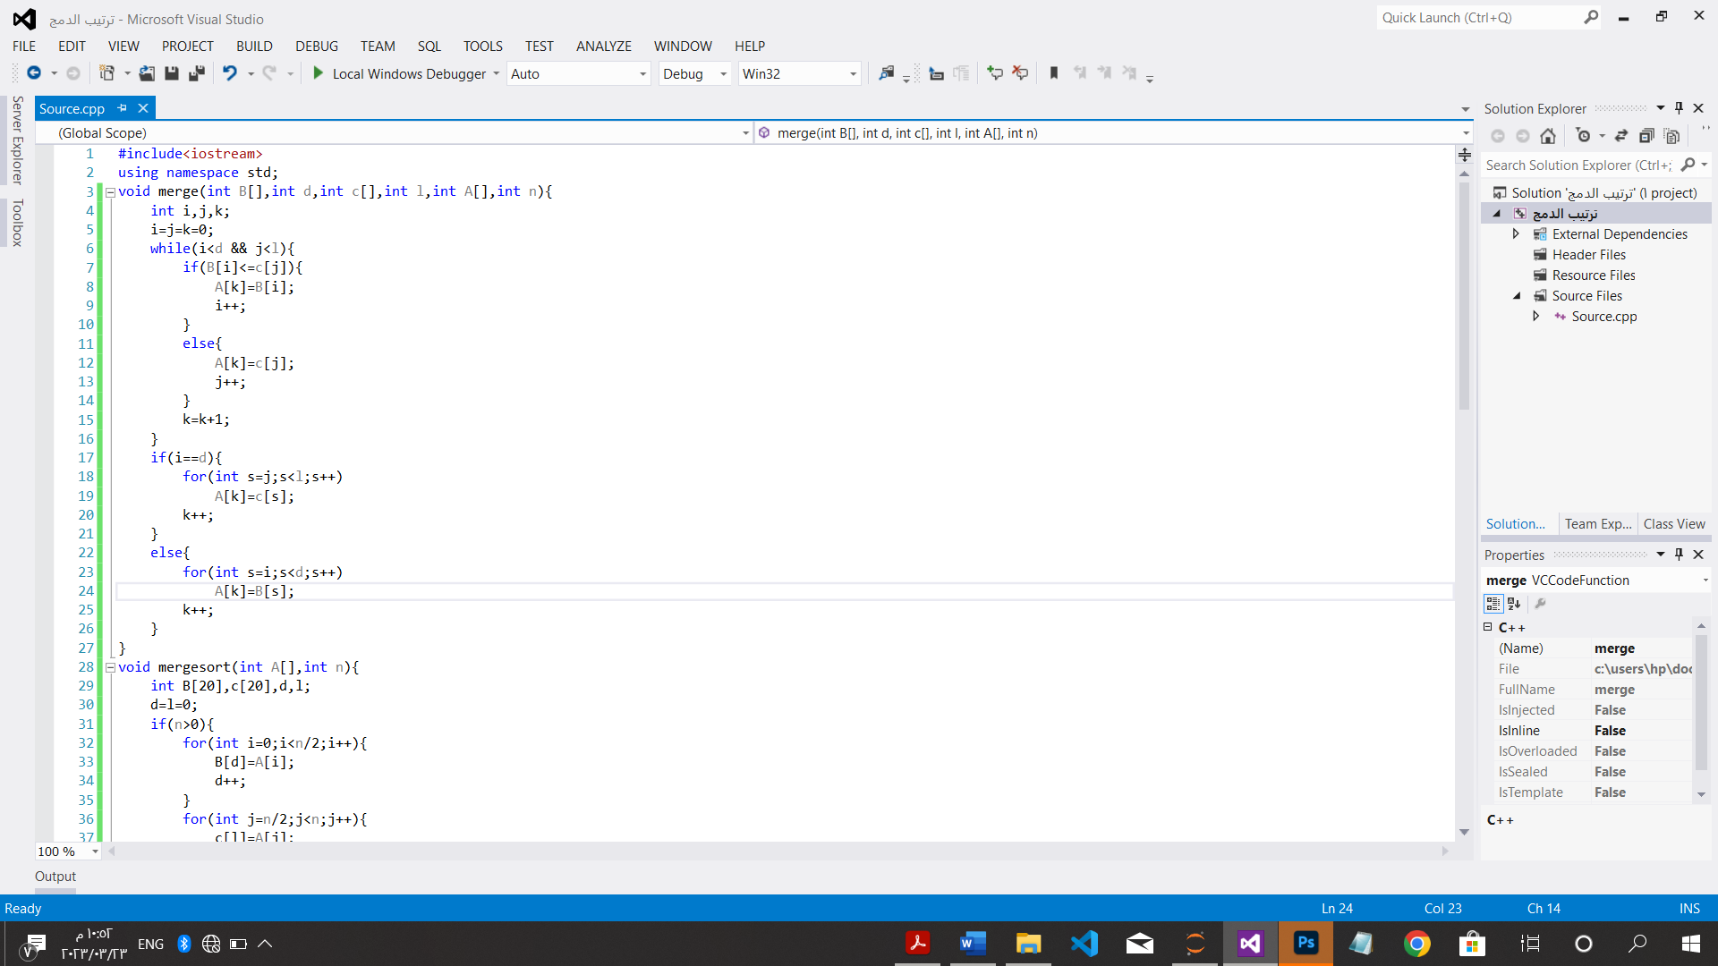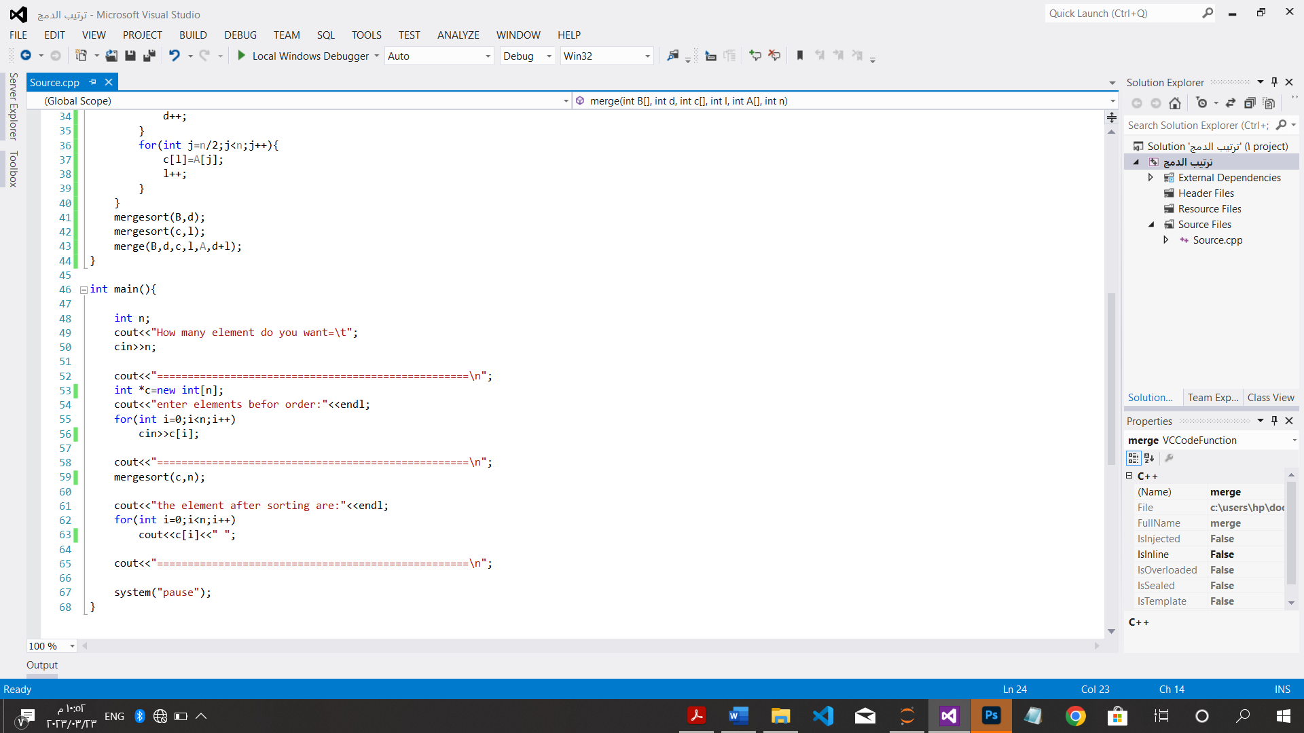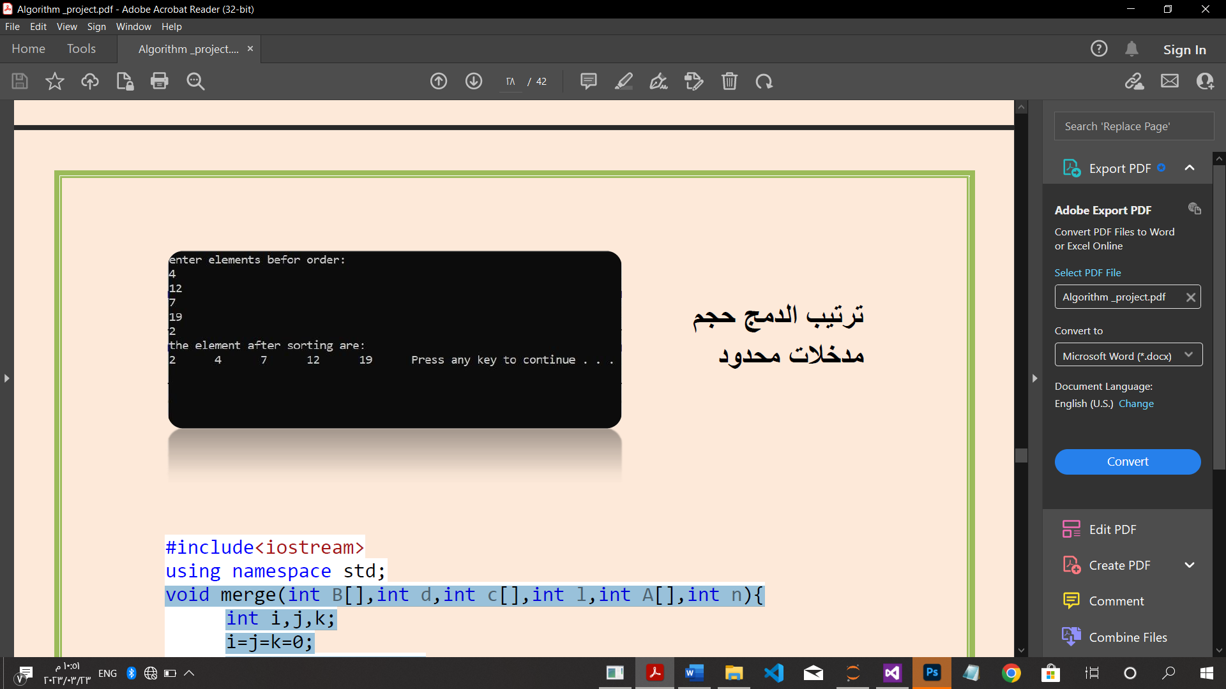

ترتيب السريع:*

#include<iostream>

using namespace std;

int partition(int A[],int l,int r){

int p,s;

p=A[l];

s=l;

for(int i=l+1;i<=r;i++)

if(A[i]<p)

swap(A[++s],A[i]);

swap(A[l],A[s]);

return s;

}

void quick1(int A[],int l,int r){

int s;

if(l<r){

s=partition(A,l,r);

quick1(A,l,s-1);

quick1(A,s+1,r);

}

}

int main(){

int x;

cout<<"How many number do you want:";

cin>>x;

int *A=new int[x],l=0;

cout<<"enter element of Array:"<<endl;

for(int i=l;i<=x;i++)

cin>>A[i];

quick1(A,l,x);

cout<<"the array after order it:"<<endl;

for(int i=l;i<=x;i++)

cout<<A[i]<<" ";

cout<<"\n===============================================\n";

system("pause");

}

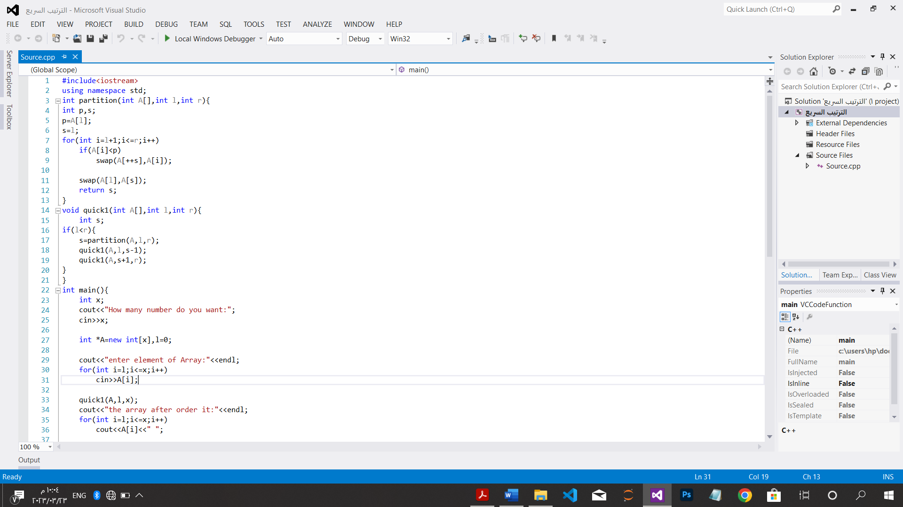

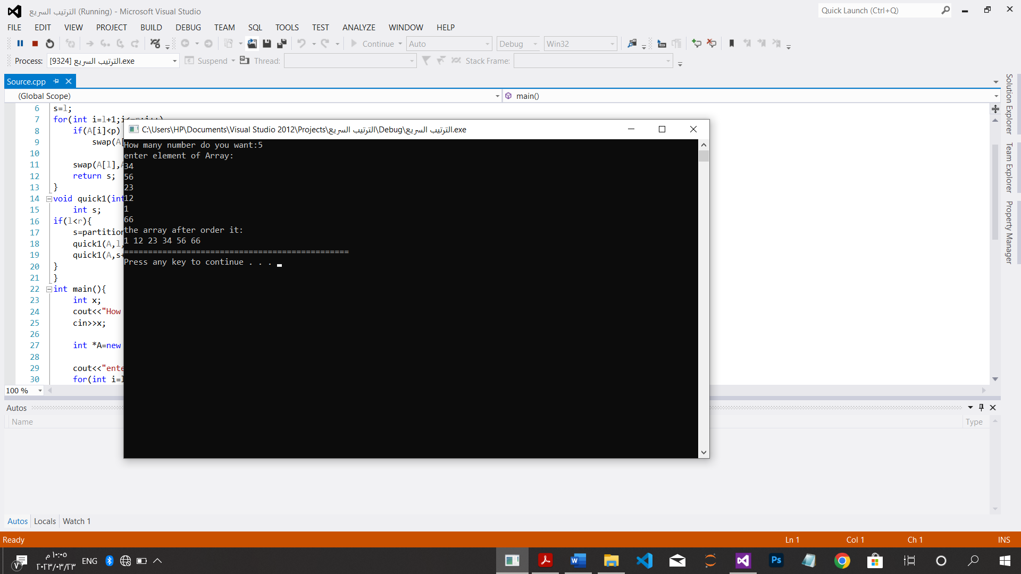

CH: 4.4 ,5.2,5.3,5.4,5.5

*البحث الثنائي تعاودياَ:

#include<iostream>

using namespace std;

int Binary(int A[],int n,int k){

int I,m,r;

i=0;r=n-1;

while(i<=r){

m=(i+r)/2;

if(k==A[m])

return m;

else if(A[m]>k)

r=m-1;

else i=m+1;

}

return -1;

}

int main(){

int k;

int A[5];

cout<<"enter ordaring Array"<<endl;

for(int i=0;i<5;i++)

cin>>A[i];

cout<<"=============================================\n";

cout<<"enter element to search about it"<<endl;

cin>>k;

cout<<"=============================================\n";

int x=Binary(A,5,k);

cout<<"the location is:"<<x<<endl;

system("pause");

}

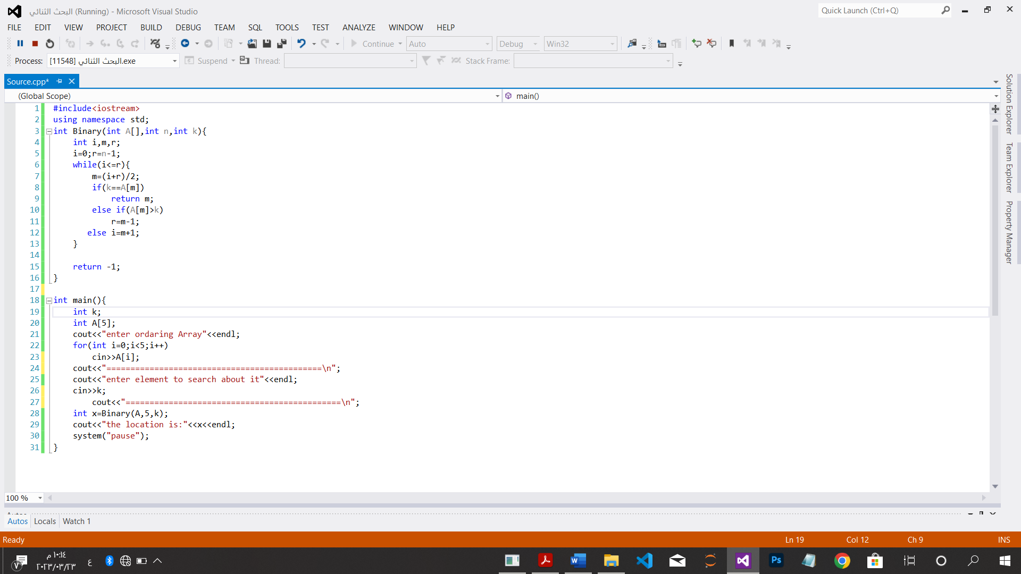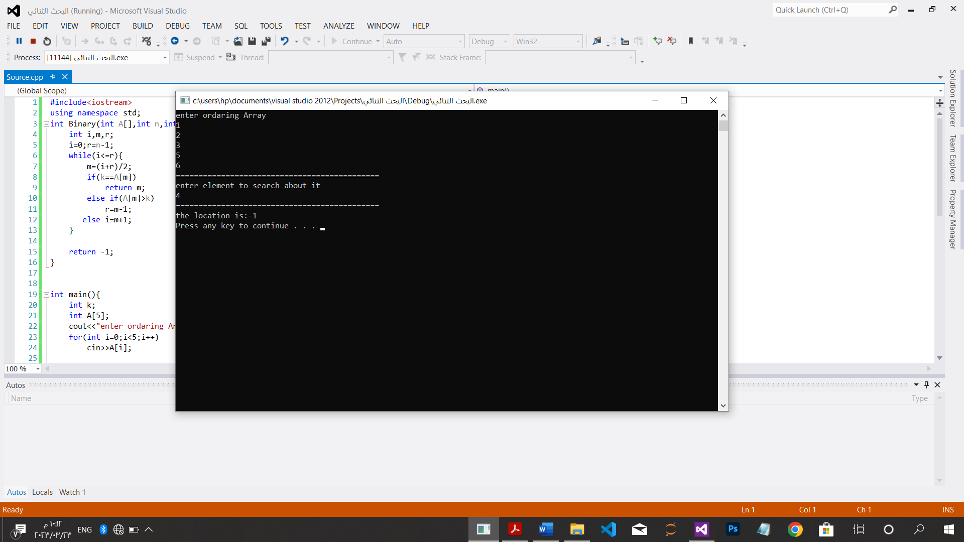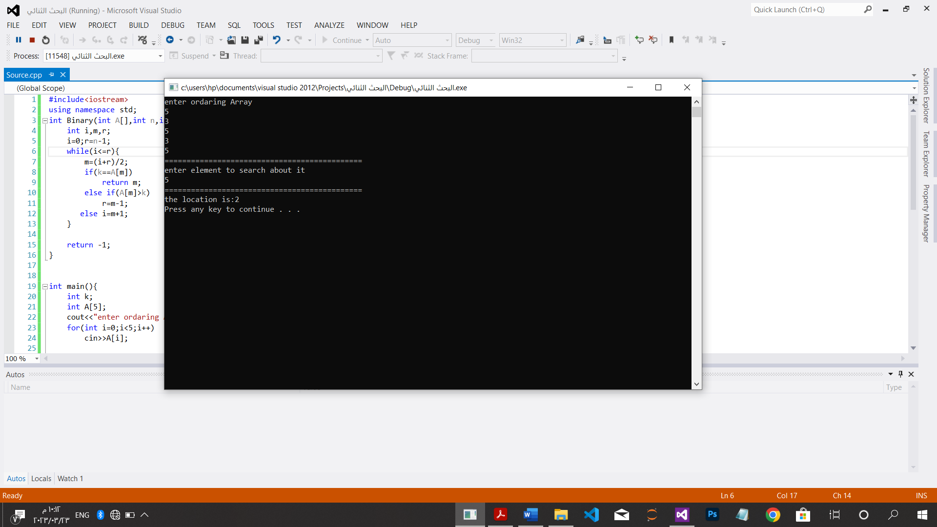

*البحث الثنائي تكرارياَ:

#include<iostream>

using namespace std;

int main(){

int k;

int I,m,n,r;

cout<<"How many element Do you want = ";

cin >>n;

int *A=new int[n];

cout<<"enter ordaring Array"<<endl;

for(int i=0;i<n;i++)

cin>>A[i];

cout<<"=============================================\n";

cout<<"enter element to search about it"<<endl;

cin>>k;

cout<<"=============================================\n";

int s=0;

for(int i=0;i<n;i++)

if(k==A[i])

s++;

if(s==0)

cout<<"number is not found\n";

else

cout<<"number is found\n";

system("pause");

}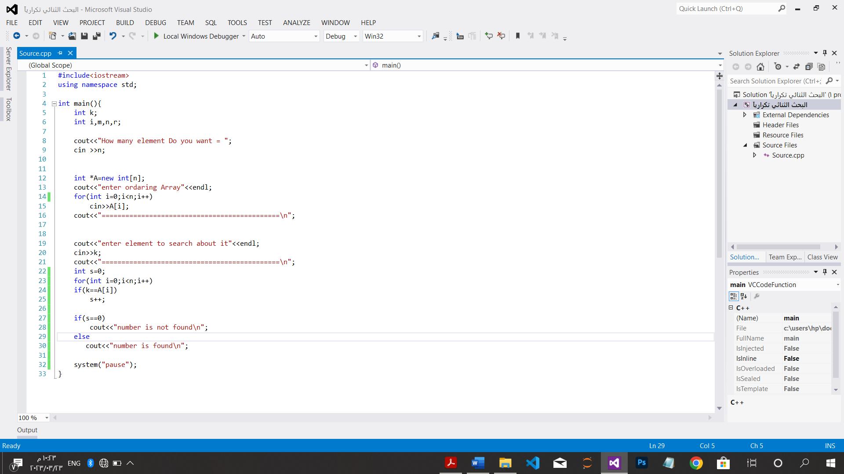

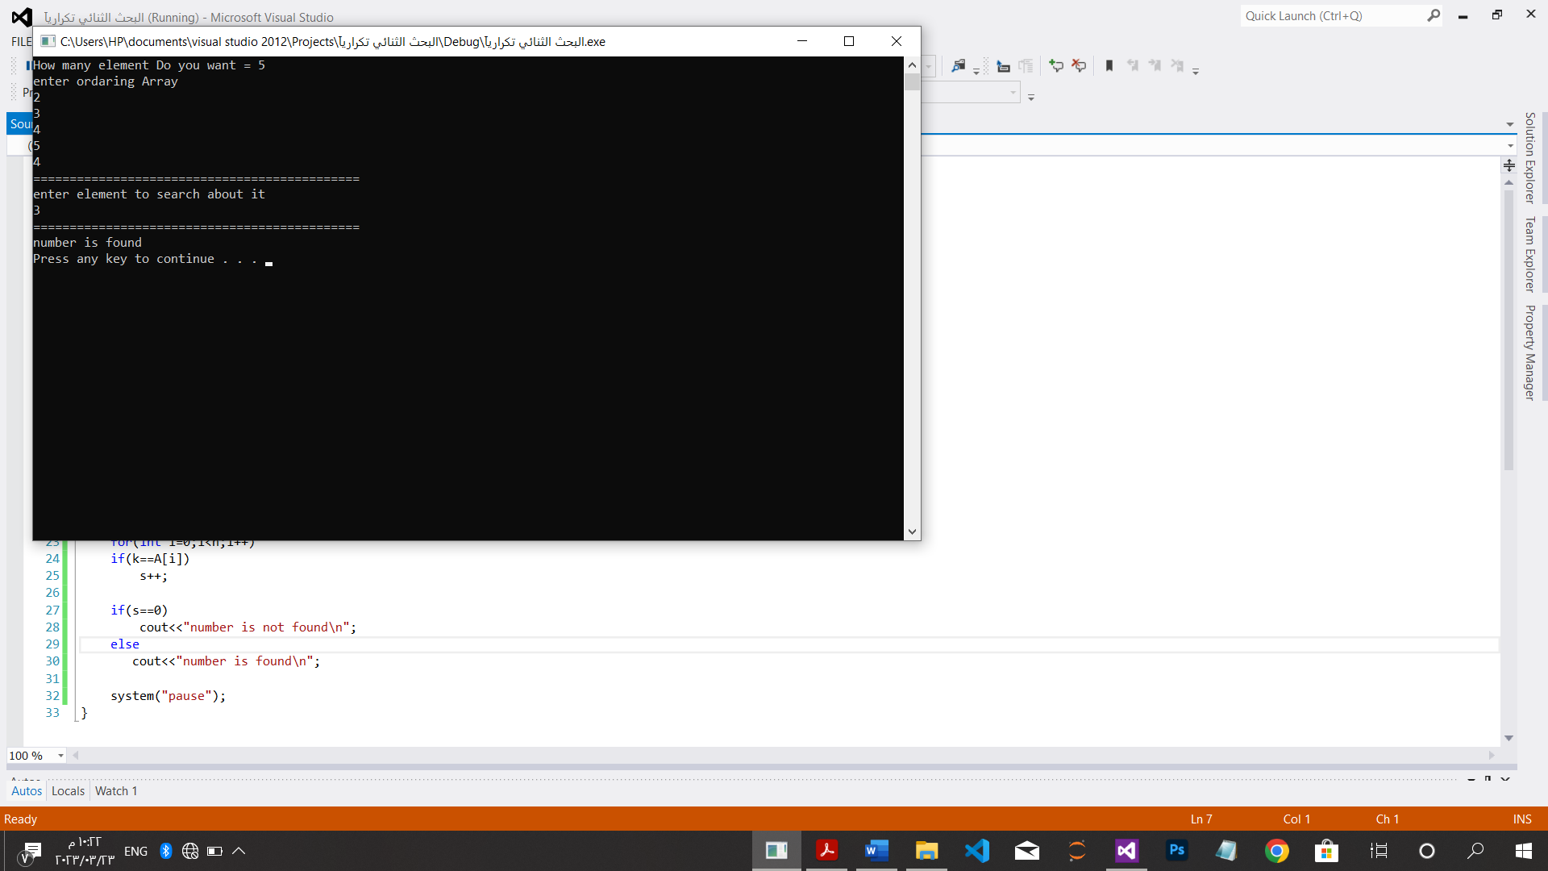

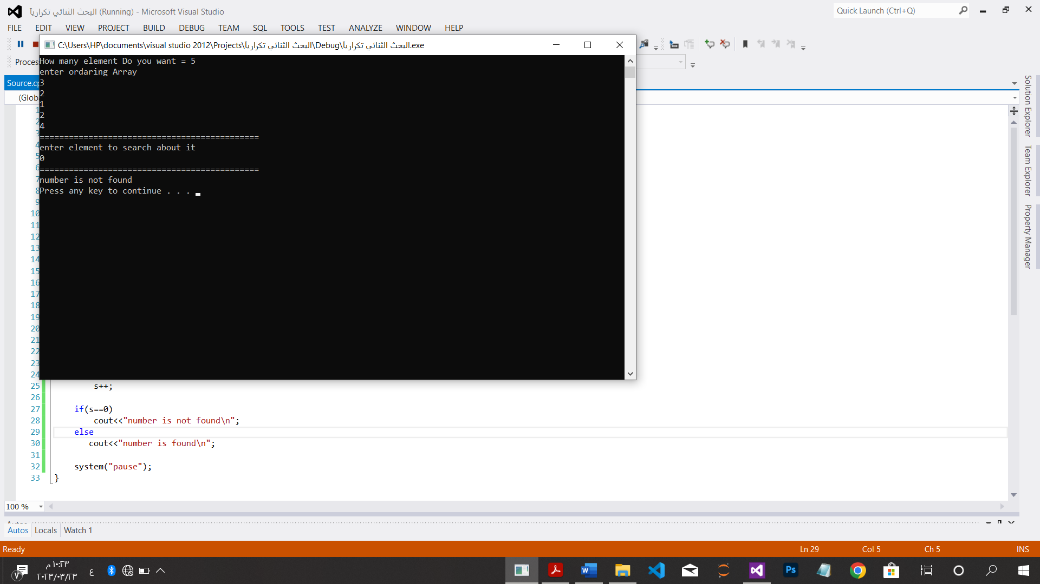

*اجتياز شجرة بترتيب سابق وداخل ولاحق:

#include<iostream>

using namespace std;

struct node{

int data;

struct node*left;

struct node*right;

};

void inorder(struct node*root){

if(root!=NULL) {

inorder(root->left);

cout<<root->data<<" ";

inorder(root->right);}

}

void post_order(struct node*root){

if(root!=NULL) {

post_order(root->left);

post_order(root->right);

cout<<root->data<<" "; }

}

void pre_order(struct node*root){

if(root!=NULL) {

cout<<root->data<<" ";

pre_order(root->left);

pre_order(root->right);}

}

node* newNode(int data){

node*Node=new node();

Node->data=data;

Node->left=NULL;

Node->right=NULL;

return(Node);

}

int main(){

node*root=newNode(1);

root->left=newNode(2);

root->right=newNode(3);

root->left->left=newNode(4);

root->left->right=newNode(8);

cout<<"inorder travales:"<<endl;

inorder(root);

cout<<endl;

cout<<"postorder travales:"<<endl;

post_order(root);

cout<<endl;

cout<<"preorder travales:"<<endl;

pre_order(root);

cout<<endl;

system("pause");

}

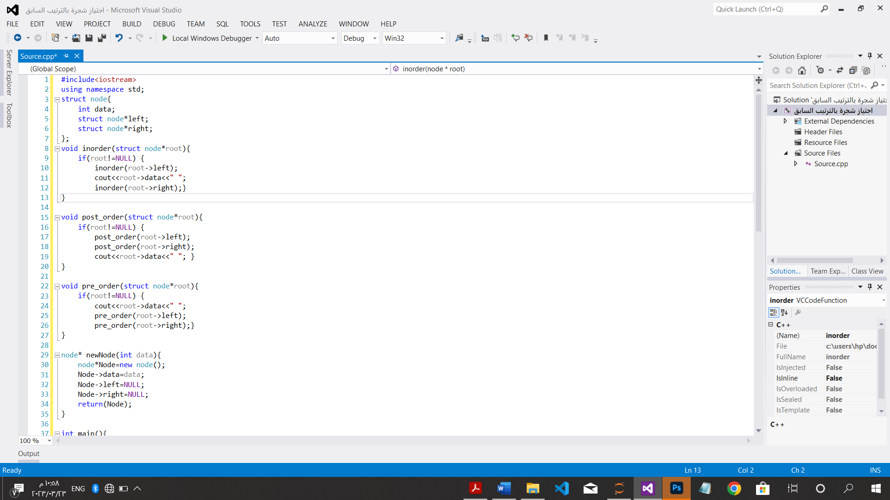

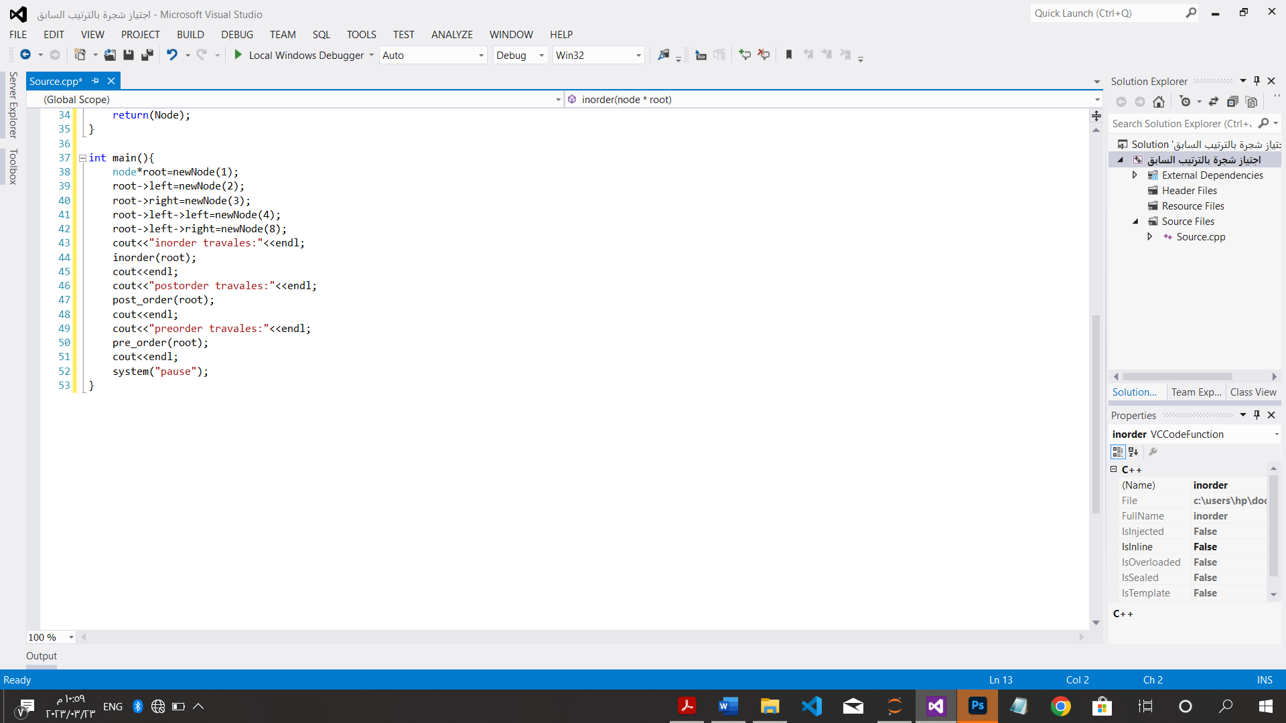

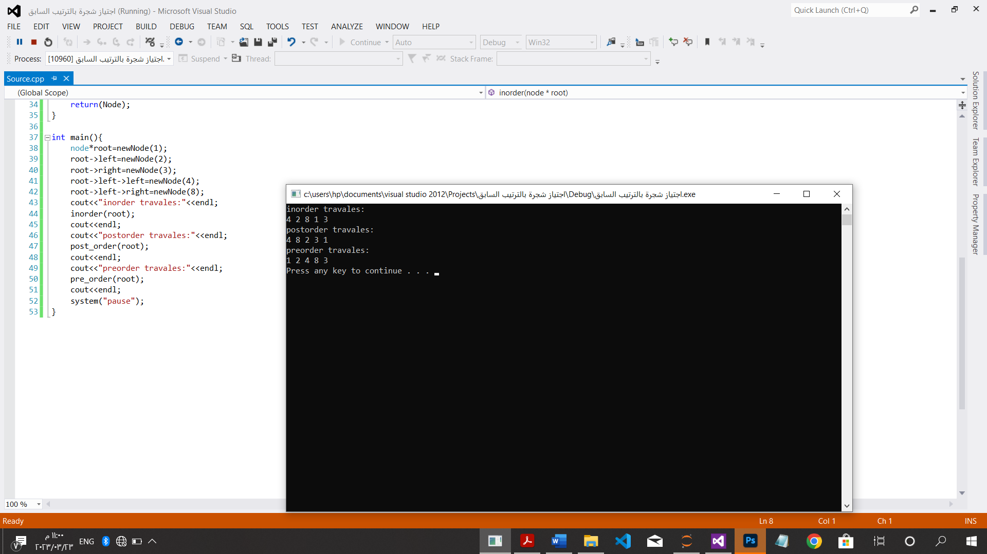

CH:4

*حساب الأس تعاودياَ باستخدام تقنية الفتح والتقليل:

#include<iostream>

using namespace std;

int exp(int a,int n){

if(n==0)

return 1;

else

return exp(a,n-1)*a;

}

int main(){

int a, n;

cout<<"enter the number:"<<endl;

cin>>a;

cout<<"enter the exp:"<<endl;

cin>>n;

cout<<"========================================\n";

cout<<"the number="<<exp(a,n)<<endl;

system("pause");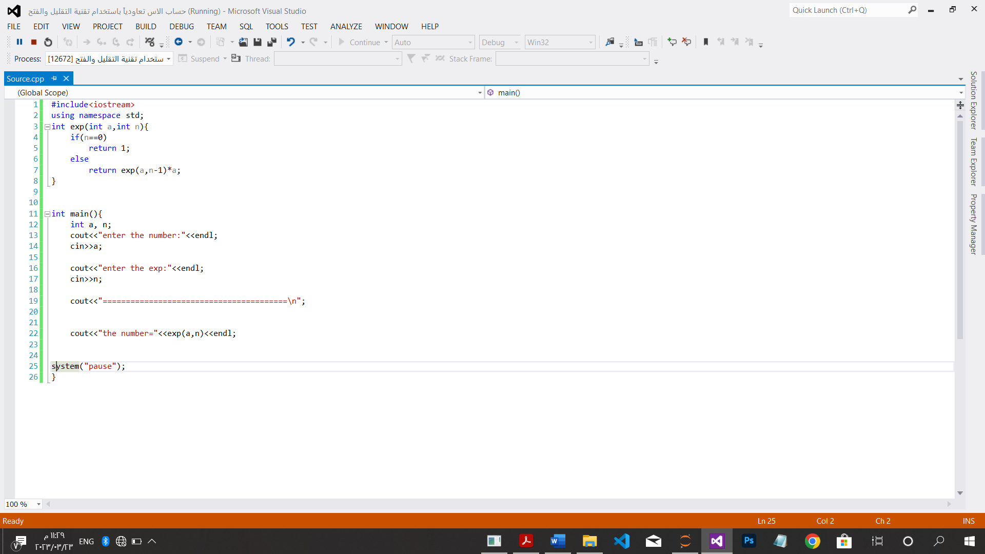

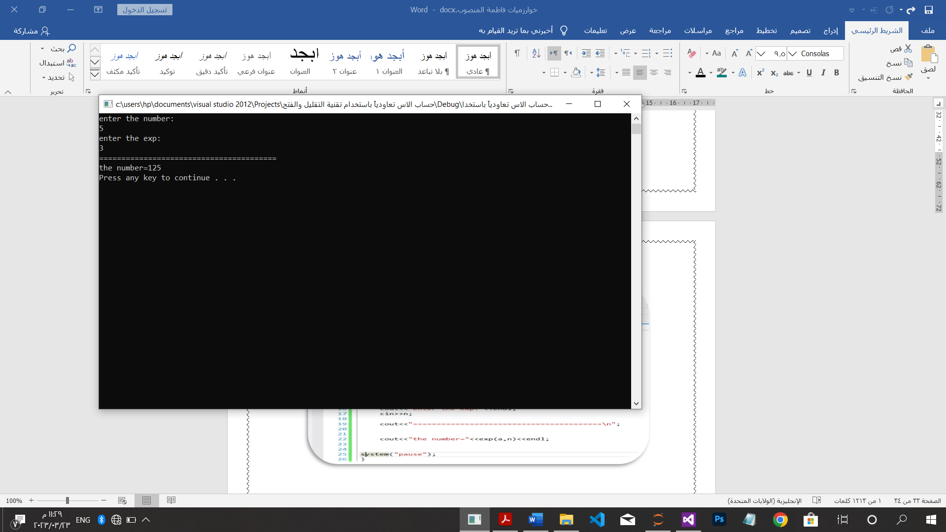

*حساب الأس بعامل ثابت باستخدام تقنية الفتح والتقليل:

#include<iostream>

using namespace std;

int exp(int a,int n){

if(n==0)

return 1;

if(n==1)

return a;

else

return exp(a,(n/2))*exp(a,(n/2));

}

int main(){

int a, n;

cout<<"enter the number:"<<endl;

cin>>a;

cout<<"enter the exp:"<<endl;

cin>>n;

cout<<"========================================\n";

cout<<"the number="<<exp(a,n)<<endl;

system("pause");

}

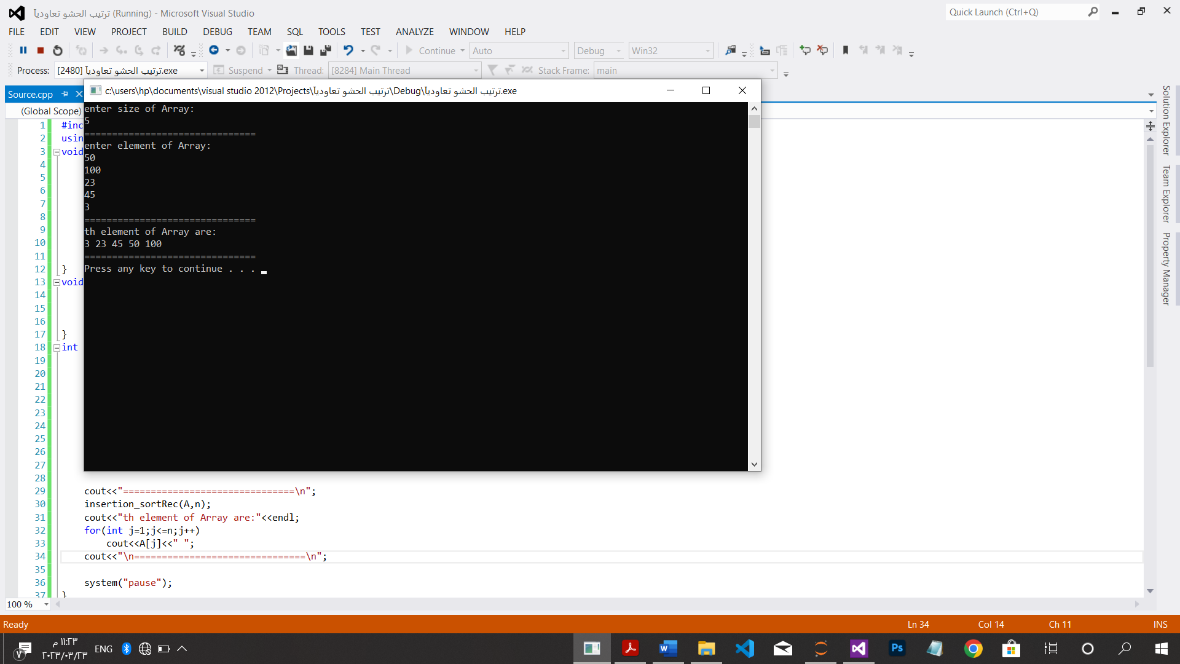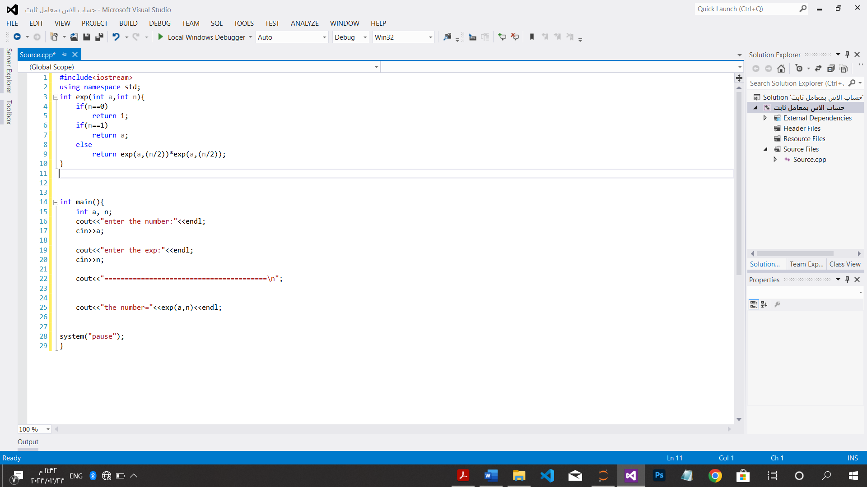

الترتيب بالحشو تعاودياَ:

#include<iostream>

using namespace std;

void insert(int A[],int n){

int key; key=A[n];

for(int j=n-1;j>=0;j--){

if(key<A[j])

A[j+1]=A[j];

else

break;

A[j]=key;

}

}

void insertion_sortRec(int A[],int n){

if(n>0)

insertion_sortRec(A,n-1);

insert(A,n);

}

int main(){

int n;

cout<<"enter size of Array:"<<endl;

cin>>n;

cout<<"===============================\n";

int*A=new int[n];

cout<<"enter element of Array:"<<endl;

for(int i=1;i<=n;i++)

cin>>A[i];

cout<<"===============================\n";

insertion_sortRec(A,n);

cout<<"th element of Array are:"<<endl;

for(int j=1;j<=n;j++)

cout<<A[j]<<" ";

cout<<"===============================\n";

system("pause");

}

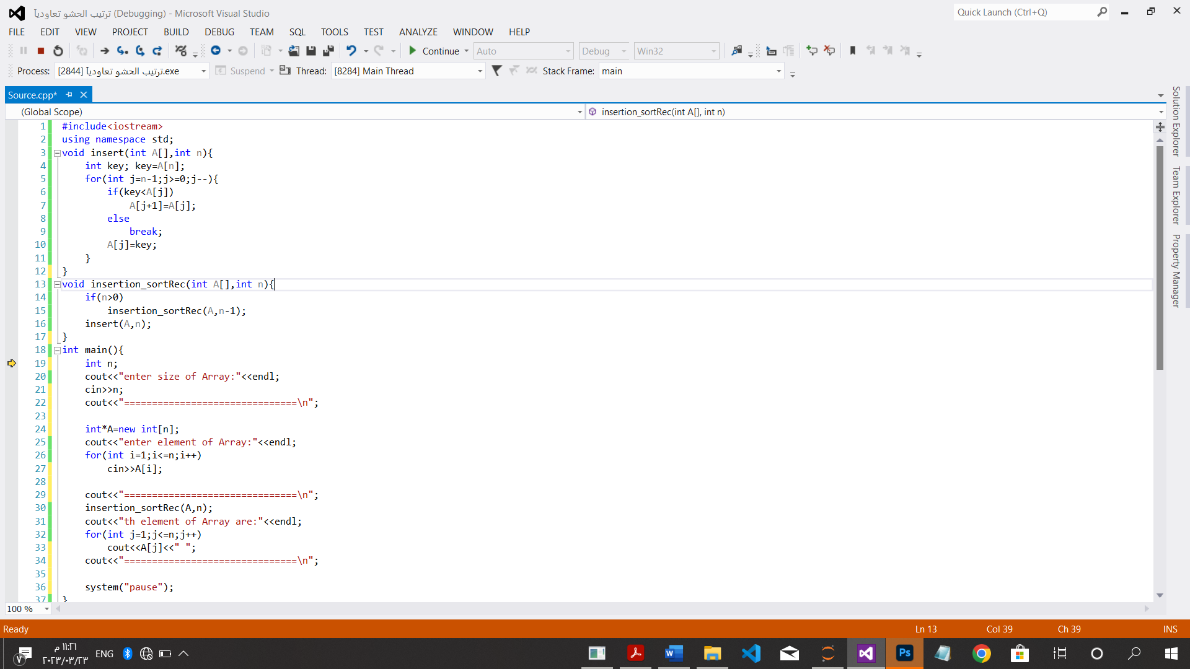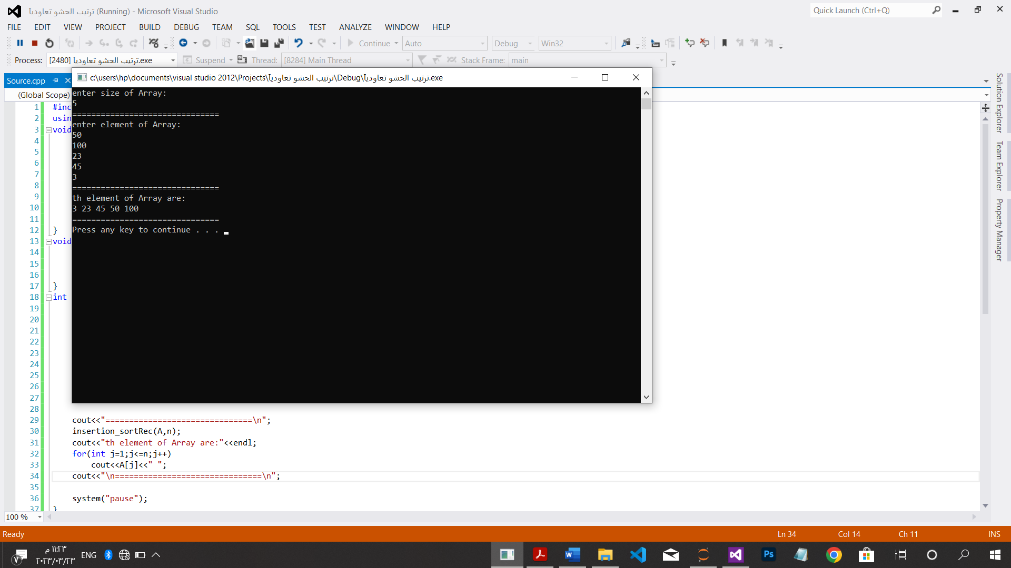

*البحث العمق أولاَ:

#include<iostream>

using namespace std;

int n,k,ns;

int g[100];

bool visit[100];

void dfs(int node){

visit[node]=1;

for(int i=n;i<node;i++) {

n=g[node];

if(!visit[n])

dfs(n);}

}

int main(){

cout<<"enter n=\t";

cin>>n;

cout<<"enter k=\t";

cin >>k;

cout<<"=============================\n";

int x,y;

for(int i=0;i<k;i++){

cout<<"enter x=\t";

cin>>x;

cout<<"enter y=\t";

cin>>y;

cout<<"=============================\n";

g[x];

g[y];

for(int i=1;i<n;i++){

if(!visit[i]){

dfs(i);

ns++;

}

}

cout<<endl<<ns-1<<endl;

}

cout<<"=============================\n";

system("pause");

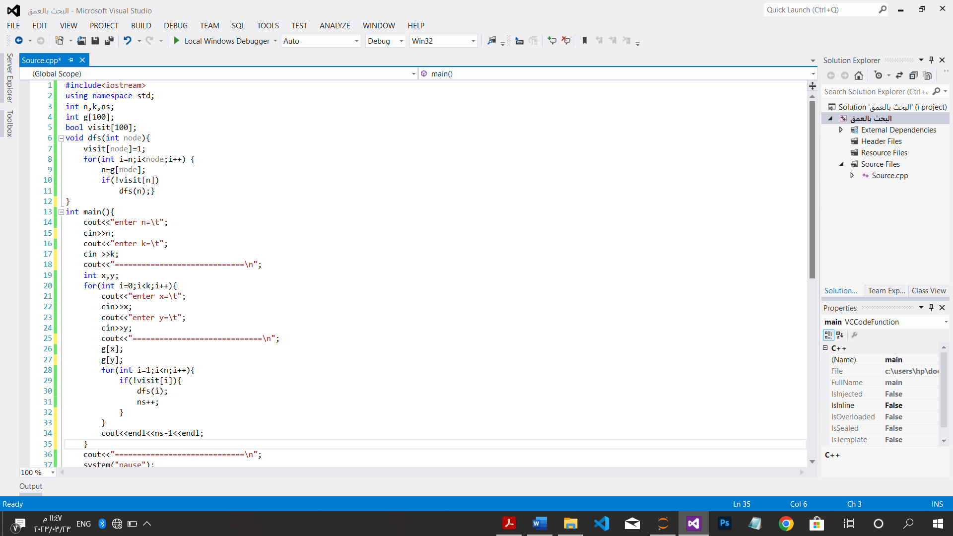

CH:6.1

*الحذف لجاوس:

#include<iostream>

using namespace std;

void main(){

int t ,x[50],i,j,k,n;

cout<<"enter element of col and row:"<<endl;

cin>>n;

int **a=new int *[n];

for(int i=0;i<n;i++)

a[i]=new int[n];

for(int i=0;i<n;i++)

for(int j=0;j<n;j++)

cin>>a[i][j];

for(i=1;i<n-1;i++){

for(j=i+1;j<n;j++){

for(k=i;k<n+1;k++){

a[j][k]=(a[j][k]-a[i][k]*a[j][i])/a[i][j];}

}

}

for(int j=n;j>1;j++){

t=0;

for(k=j+1;k<n;k++){

t=t+a[j][k]*x[k];

x[j]=(a[j][n+1]-t)/a[j][j];}

}

for(int i=0;i<n;i++)

cout<<x[i]<<" ";

system("pause");

}

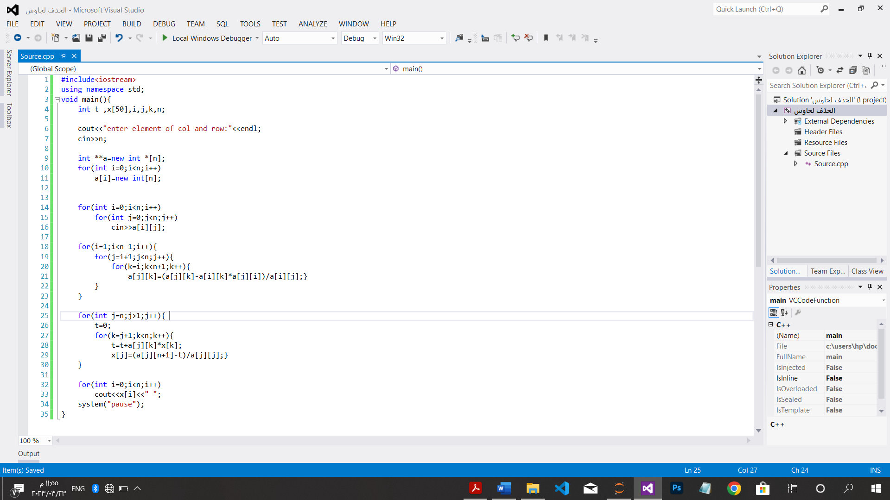

*قاعدة هورنر:

#include<iostream>

using namespace std; int Horner(float p[],int n,int x){

int P;

P=p[n];

for(int i=n-1;i>=1;i--)

P=P*x+p[i];

return P;

}

int main(){

float p[40],n,x,c;

cout<<"enter number of coefficients"<<endl;

cin>>n;

cout<<"enter numbers:"<<endl;

for(int i=1;i<=n;i++)

cin>>p[i];

cout<<"enter number x:"<<endl;

cin>>x;

c=Horner(p,n,x);

cout<<"the value of polynomial"<<c<<endl;

system("pause");

} 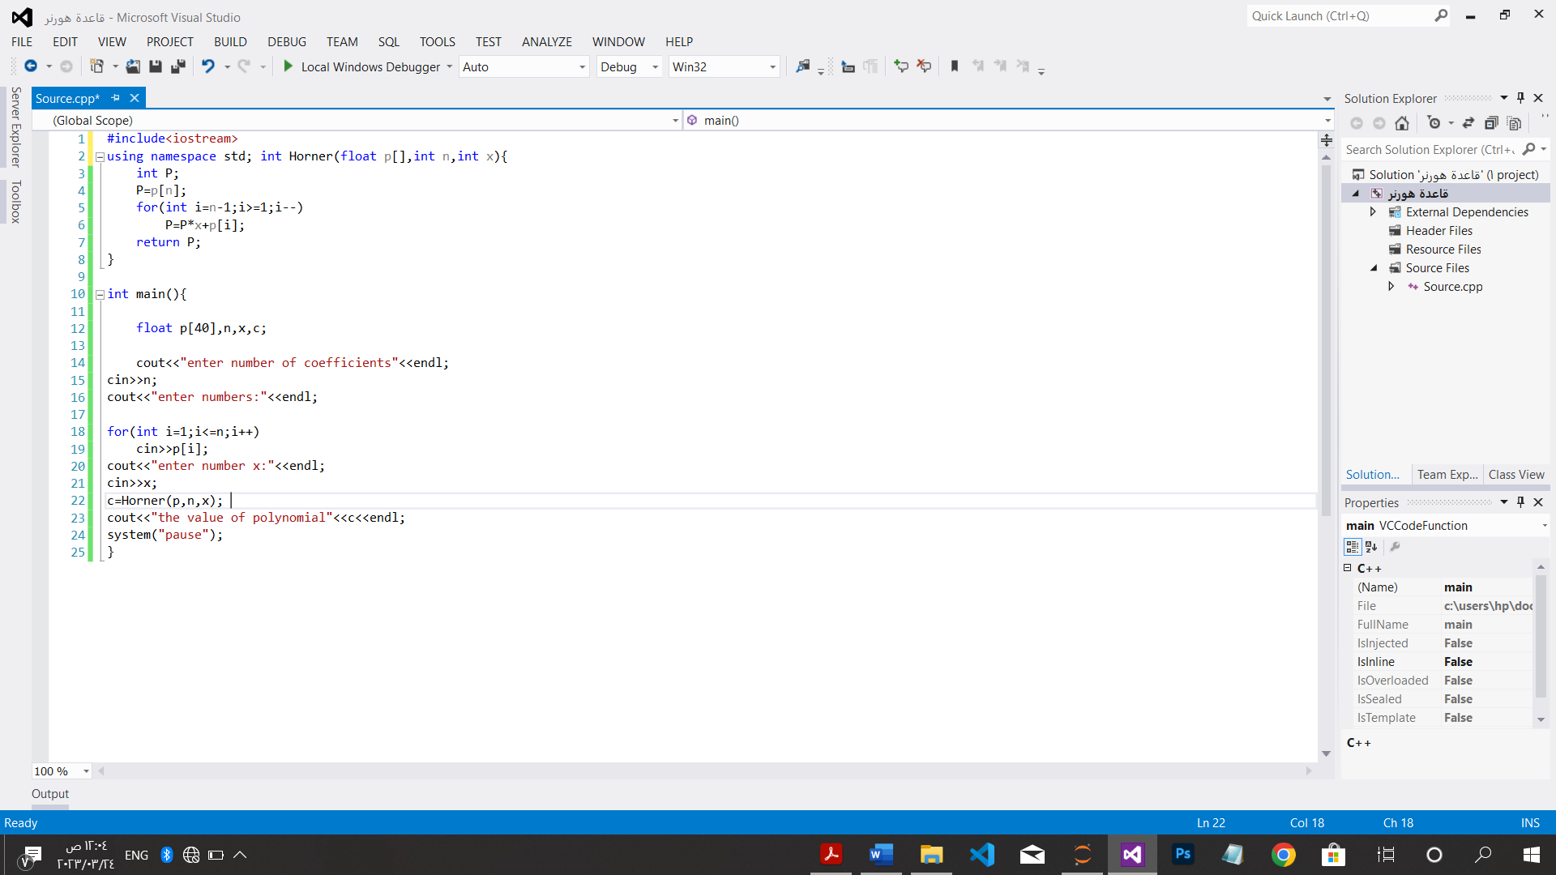

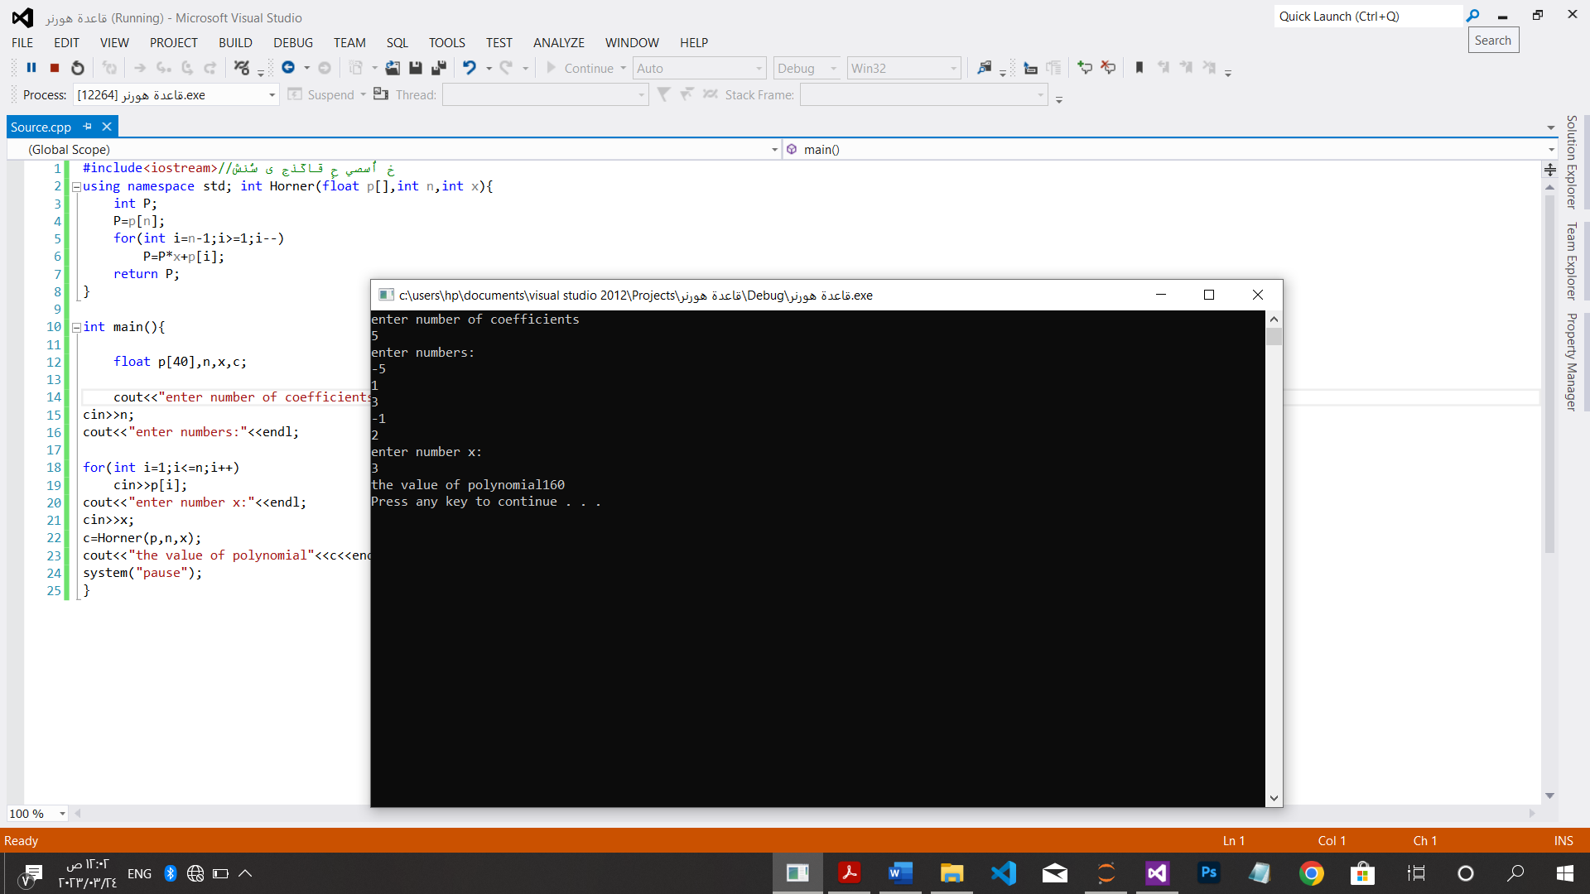

CH:6.2

*بناء الكومة من اسفل لاعلى:

#include<iostream>

using namespace std;

int left1(int i){

return 2*i;

}

int right1(int i){

return 2*i+1;

}

void maxHeapify(int H[],int i,int n){

int l,r,largest;

l=left1(i);

r=right1(i);

if(l<=n && H[l]>H[i])

largest=l;

else largest=i;

if(r<=n && H[r]>H[largest])

largest=r;

if(largest!=i)

swap(H[i],H[largest]);

}

void HeapBottom(int H[],int n){

for(int i=1;i<=n/2;i++)

maxHeapify(H,i,n);

}

int main(){

int n;

cout<<"How many element do you want:\t";

cin>>n;

int *H=new int[n];

cout<<"enter element of Heap:"<<endl;

for(int i=1;i<=n;i++)

cin>>H[i];

HeapBottom(H,n);

cout<<"\n===========================================\n";

cout<<"the elemets of Heap are:"<<endl;

for(int i=1;i<=n;i++)

cout<<H[i]<<" ";

cout<<"\n===========================================\n";

system("pause");

}

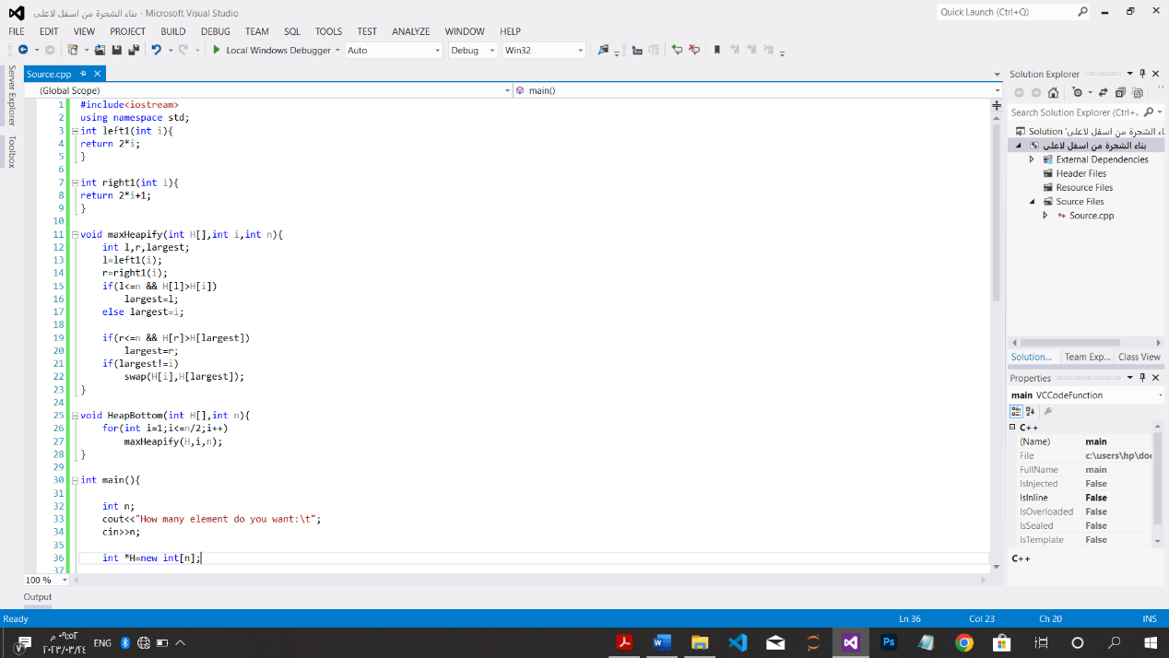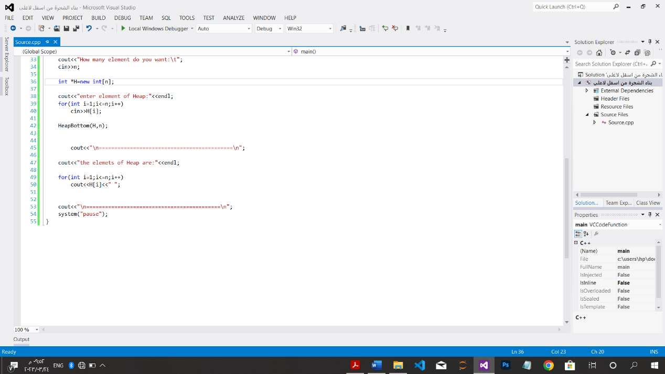

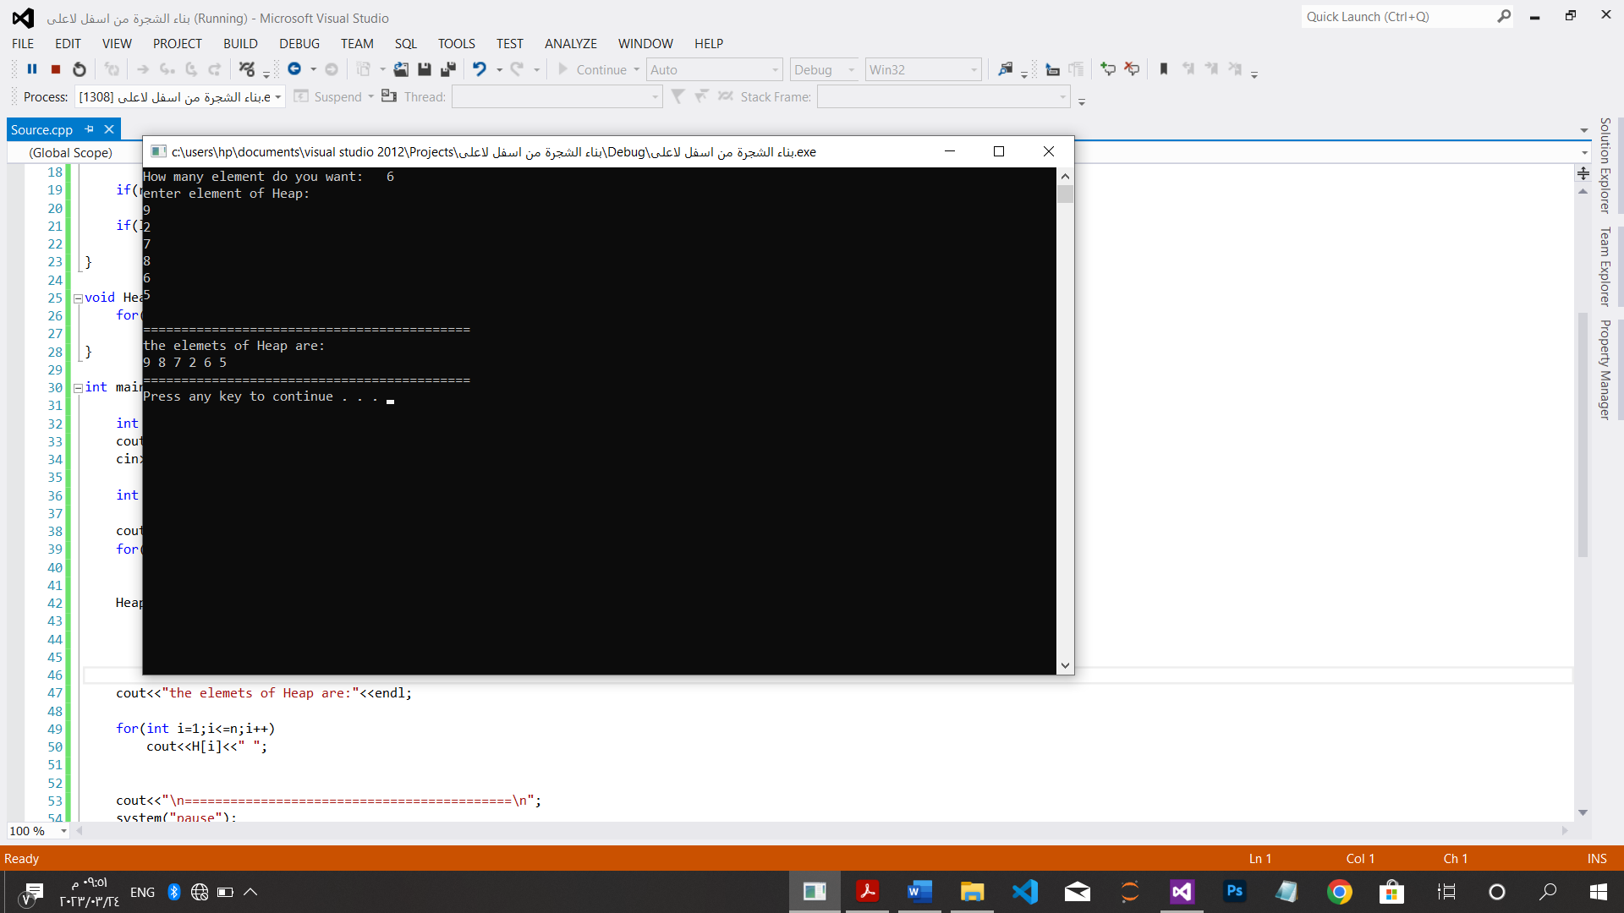

*إضافة عنصر والحذف على الكومة:

#include<iostream>

using namespace std;

void heapify(int arr[],int n,int i){

int largest=i;

int l=2*i+1;

int r=2*i+2;

if(l<n && arr[i]>arr[largest])

largest=l;

if(r<n && arr[r]>arr[largest])

largest=r;

if(largest!=i){

swap(arr[i],arr[largest]);

heapify(arr,n,largest);}

}

void deletroot(int arr[],int &n){

int lastelement=arr[n-1];

arr[0]=lastelement;

n=n-1;

heapify(arr,n,0);

}

void insertNode(int arr[],int&n ,int key){

n=n+1;

arr[n-1]=key;

heapify(arr,n,n-1);

}

void printArray(int arr[],int n){

for(int i=0;i<n;++i)

cout<<arr[i]<<" "; cout<<endl;

}

int main(){

int n;

cout<<"How many number do you want:\t";

cin>>n;

int key=18;

int *arr=new int [n];

cout<<"enter element of array\n";

for(int i=0;i<n;++i)

cin>>arr[i];

cout<<"==================================================\n";

cout<<"print the elements before any opertion:\n";

printArray(arr,n);

cout<<"==================================================\n";

cout<<"the elements of array after insert node are:"<<endl;

insertNode(arr,n,key);

printArray(arr,n);

cout<<"==================================================\n";

cout<<"the elements of array after delet node are:"<<endl;

deletroot(arr,n);

printArray(arr,n);

cout<<"==================================================\n";

system("pause");

}